# Diagram, text Description automatically generated[https://avatars2.githubusercontent.com/u/4156894?v=3&s=100](http://www.calstatela.edu/centers/hipic) CIS5560 Term Project Tutorial

**Authors:** Anusha Valasapalli,

Naga Sai Lohitha Karmuru,

Rishabh Shah,

Wethanie Law

**Instructor:** Jongwook Woo

**Date: 05/22/2023**

**Lab Tutorial**

Anusha Valasapalli (avalasa@calstatela.edu)

Naga Sai Lohitha Karmuru (nkarmur@calstatela.edu)

Rishabh shah ([rshah39@calstatela.edu](mailto:rshah39@calstatela.edu))

Wethanie Law (wlaw4@calstatela.edu)

**USA Used Car Dataset**

**Predictive Analysis using machine learning models in Spark ML**

**Objectives**

The objective of the lab is to build a model that predicts the price of the used car considering the features of the Item and User Details using the following machine learning algorithms:

**Used Car Price Prediction**

Linear Regression

Decision Tree Regression

Random Forest Regression

Gradient Boost Tree Regression

**Event-Type Prediction**

Decision Tree Classifier

You will learn how to build the above-listed regression and classification model.

**Platform Specifications**

**Version:** 3.2.1-amzn-3.1

**CPU Speed:** 2.40 GHz

**# of CPU cores:** 4

**# Number of nodes:** 3

**Total Memory Size:** 481GB

**Dataset Specifications**

**Dataset Name:** US Used Car Dataset

**Dataset Size:** 9.98 GB

**Dataset URL:** <https://www.kaggle.com/datasets/ananaymital/us-used-cars-dataset>

**Dataset Format:** CSV

**Step 1: Get data manually from the Data source.**

**We first need to Download the dataset from Kaggle.**

1. log in to Kaggle.

2. Download the 9.9 GB csv dataset file from the Kaggle

3. Using Python code, remove 2 GB of data from the 9.9 GB csv and use that 2 GB file in the data bricks.

**Step 2: Upload data to Databricks.**

1)Log into data bricks using the below URL.

<https://community.cloud.databricks.com/?o=999471079023550#>

**Step 3: Create a cluster in the data bricks.**

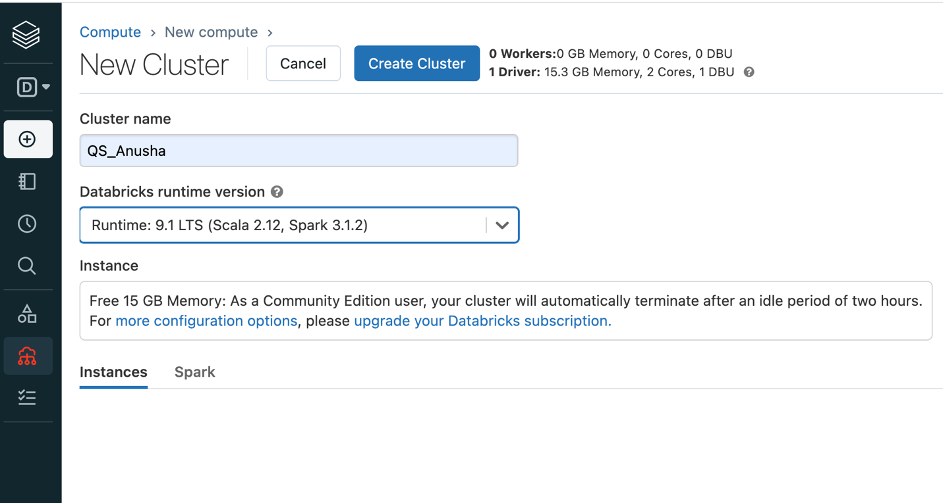

**Step 4: Upload the US Used Car dataset CSV file into the Databricks data and click Create notebook.**

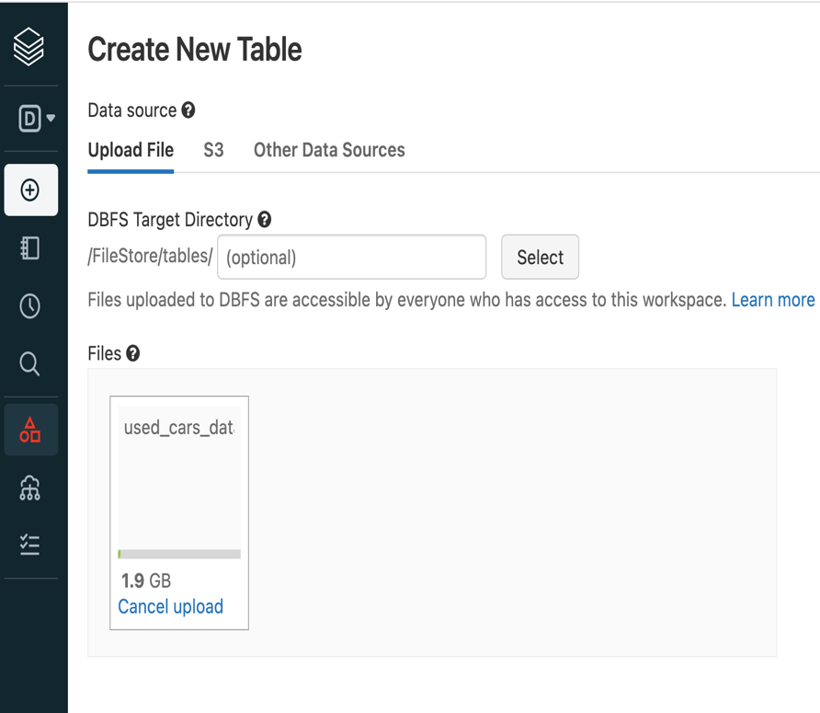

**Once the file is uploaded, you can see Create Table in Notebook. Select “Create Table in Notebook.” It automatically generates a Spark and markdown codes in the notebook, which reads the data.**

**file and display it.**

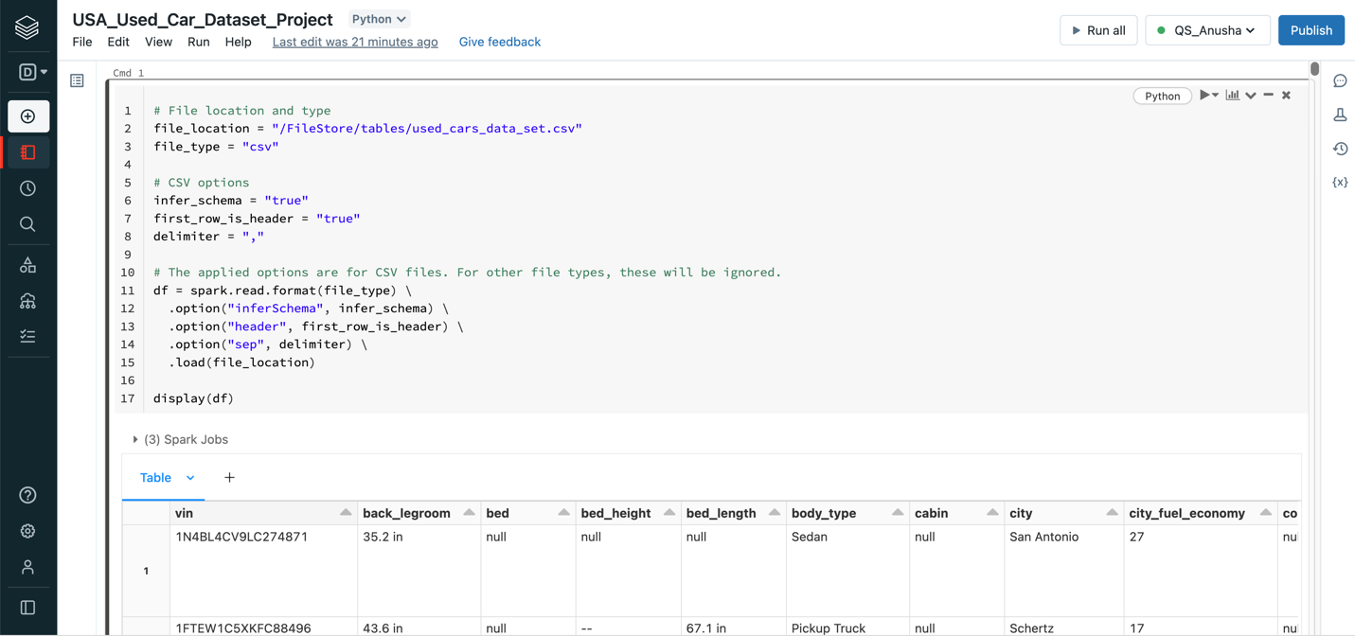

**Step 5: Create a temporary view of the table to use as a table name of Spark SQL.**

temp_table_name = "used_cars_data_set_Csv"

df.createOrReplaceTempView(temp_table_name)

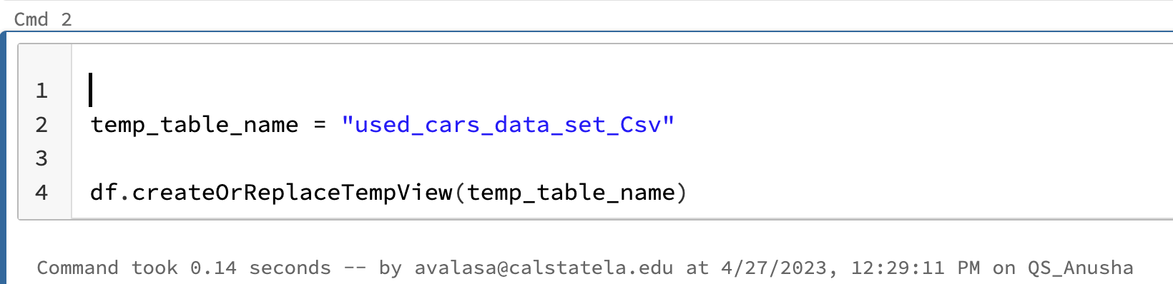

**Step 6: To see the data in the CSV file use this code df. take(10)**

df.take(10)

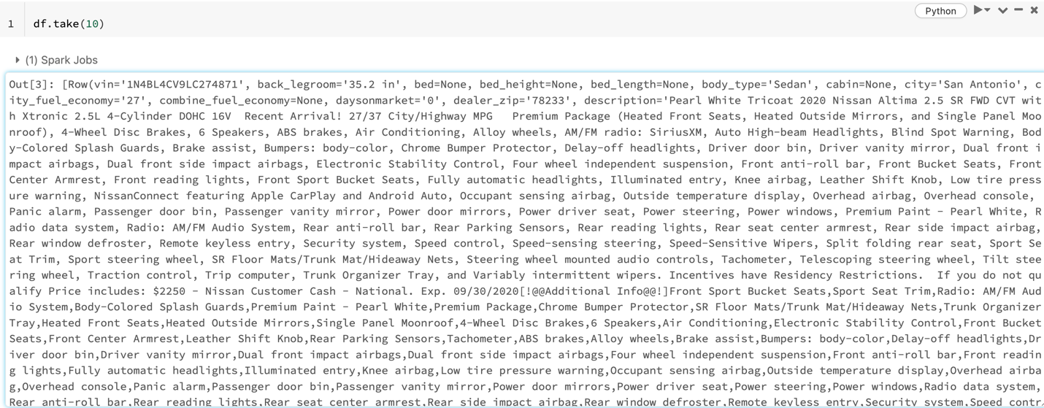

**Step 7: To check the data type of the parameter use the below code**

df.dtypes

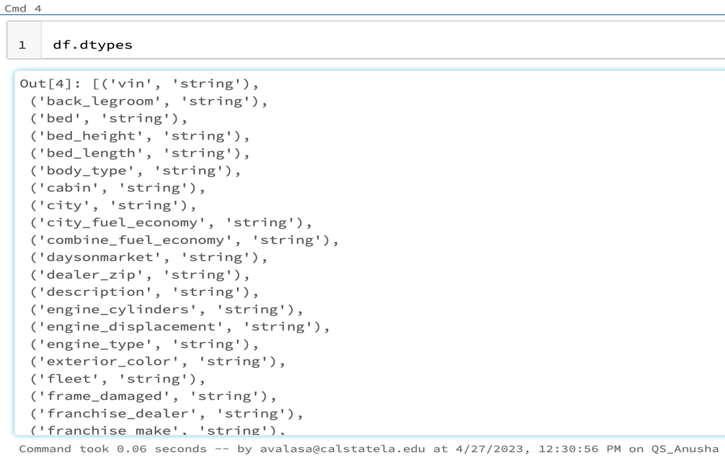

**Step 8: Import the statements.**

import pyspark

from pyspark.sql import SparkSession

from pyspark.sql.functions import col, lit

from pyspark.sql.types import StructType, StructField, StringType,IntegerType

from pyspark.sql.types import *

from pyspark.sql.functions import *

from pyspark.ml.regression import RandomForestRegressor, LinearRegression, GBTRegressor

from pyspark.ml.linalg import Vectors

from pyspark.ml import Pipeline

from pyspark.ml.tuning import ParamGridBuilder,TrainValidationSplit, CrossValidator

from pyspark.ml.tuning import CrossValidator

from pyspark.ml.classification import DecisionTreeClassifier, LogisticRegression

from pyspark.ml.feature import VectorAssembler, StringIndexer, VectorIndexer, MinMaxScaler

from pyspark.ml.evaluation import BinaryClassificationEvaluator

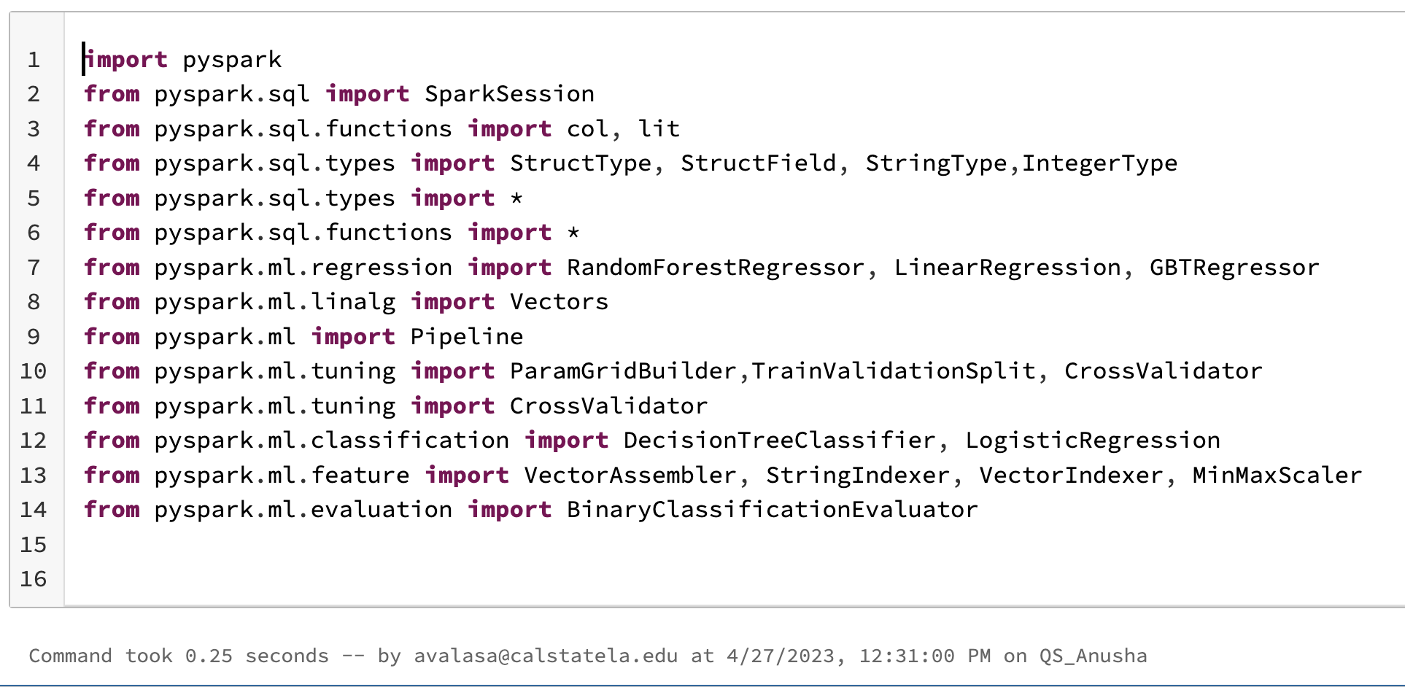

**Step 9: Typecast string to int or float.**

df2 = df.withColumn("year",col("year").cast("int")).withColumn("city_fuel_economy",col("city_fuel_economy").cast("float")).withColumn("price",col("price").cast("float")).withColumn("mileage",col("mileage").cast("float")).withColumn("owner_count",col("owner_count").cast("int")).withColumn("latitude",col("latitude").cast("float")).withColumn("highway_fuel_economy",col("highway_fuel_economy").cast("float"))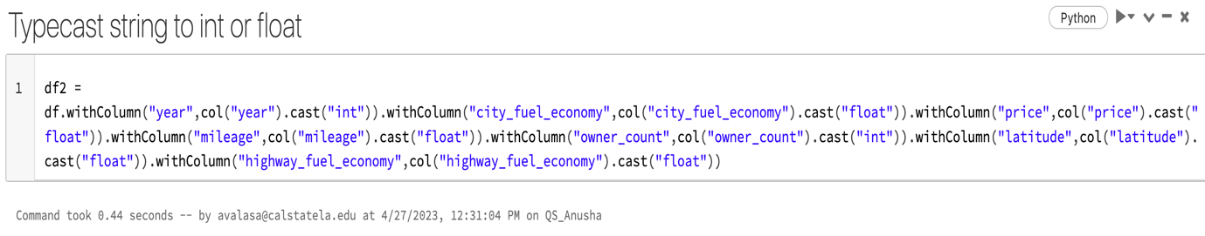

**Step 10:After converting the string to In and float, see the results with the following command.**

display(df2.select("year", "city_fuel_economy", "price", "mileage", "owner_count", "latitude", "highway_fuel_economy"))

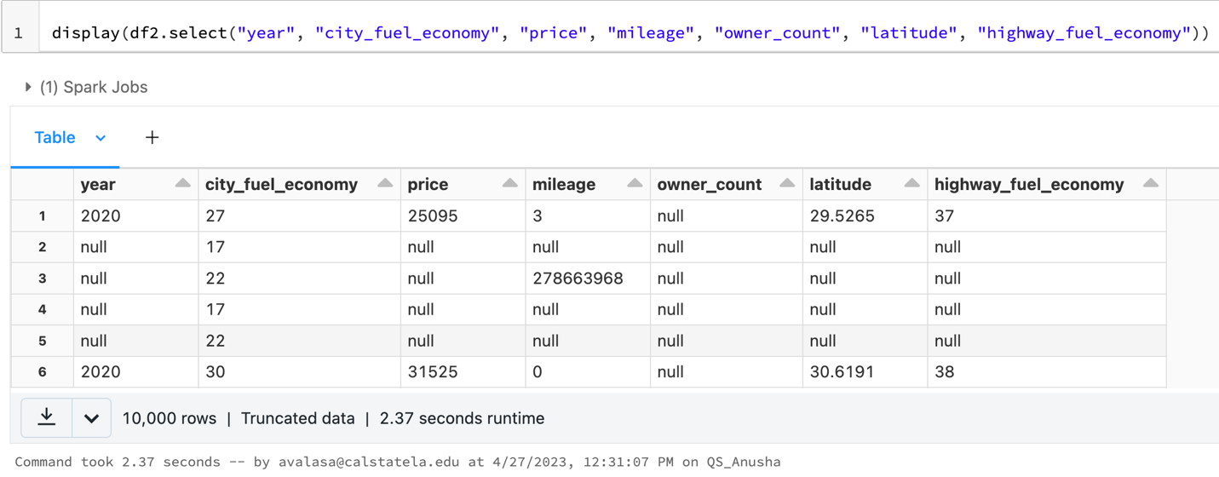

**Step 11: Convert dataset to pandas.**

df3 = df2.toPandas()

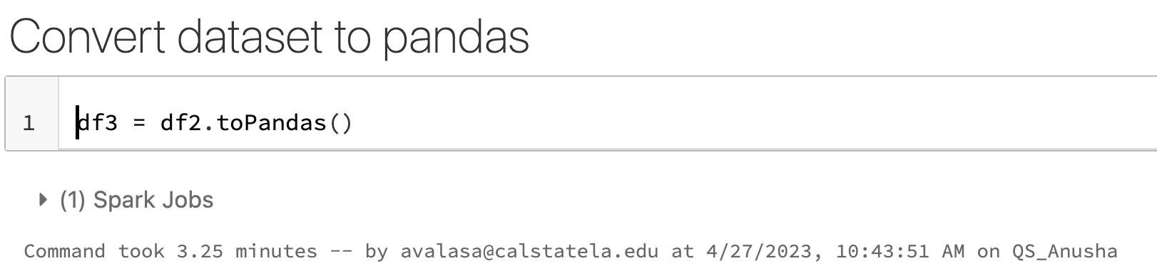

**Step 12:Remove the null values and filter the price to more than 100,000**

df2.na.drop(subset=["price", "year", "city_fuel_economy", "mileage", "owner_count", "highway_fuel_economy"])

df22 = df2.filter(col("price") < 100000)

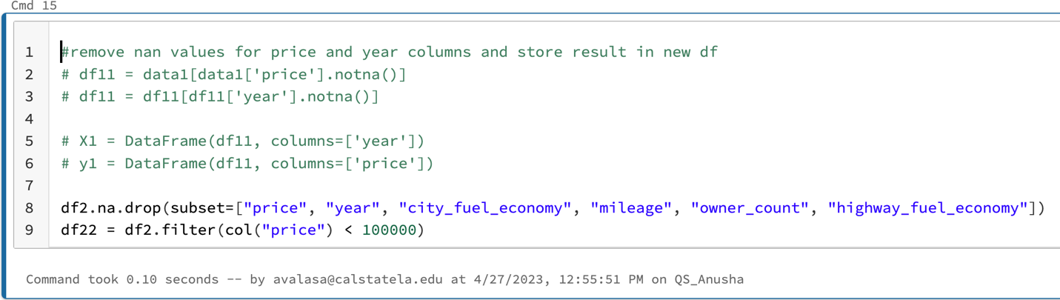

**STEP 13:Split the data into Train and Test datasets.**

splits = df22.randomSplit([0.7, 0.3])

train = splits[0]

test = splits[1]

train_rows = train.count()

test_rows = test.count()

print("TRAINING ROWS:", train_rows, "TESTING ROWS:", test_rows)

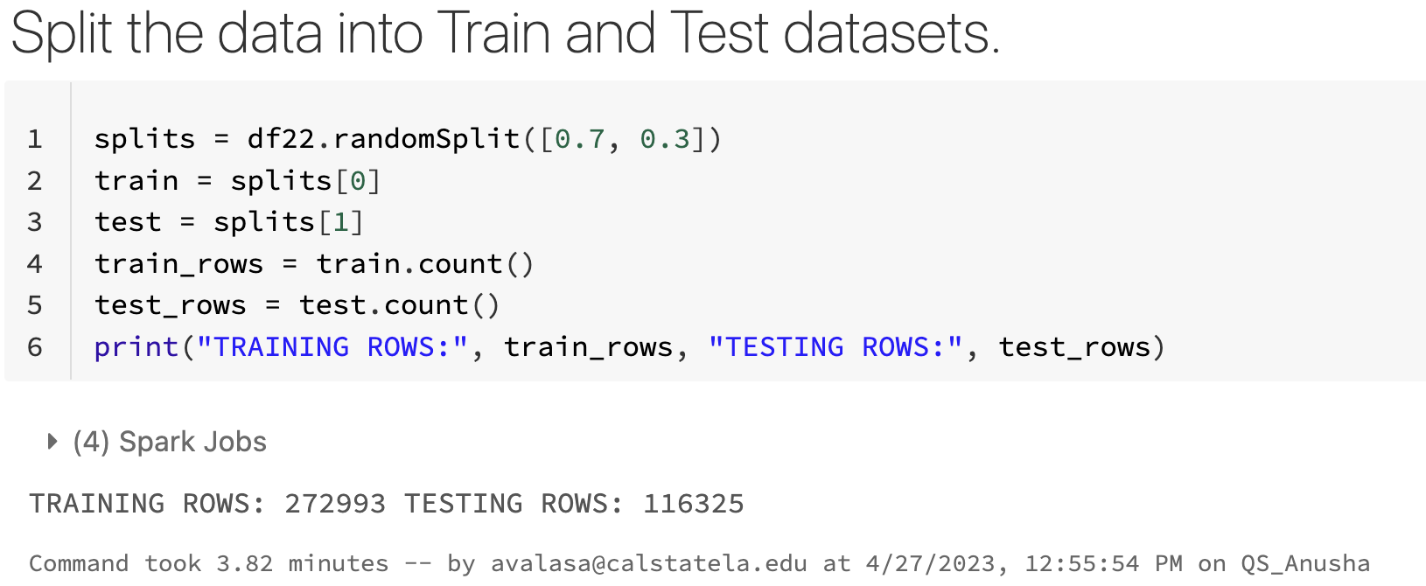

**Working with Machine Learning Algorithms: -**

**Algorithm 1: Linear Regression**

**1)Create a vector assembler with input columns**

assembler = VectorAssembler(inputCols = ["year", "city_fuel_economy", "mileage", "owner_count", "highway_fuel_economy"], outputCol="features").setHandleInvalid("skip")

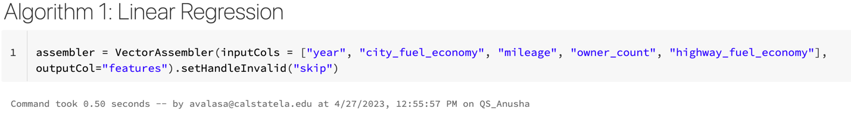

**2)Create a training data frame with a vector assembler.**

training = assembler.transform(train).select(col("features"), (col("price").cast("Int").alias("label")))

training.show()

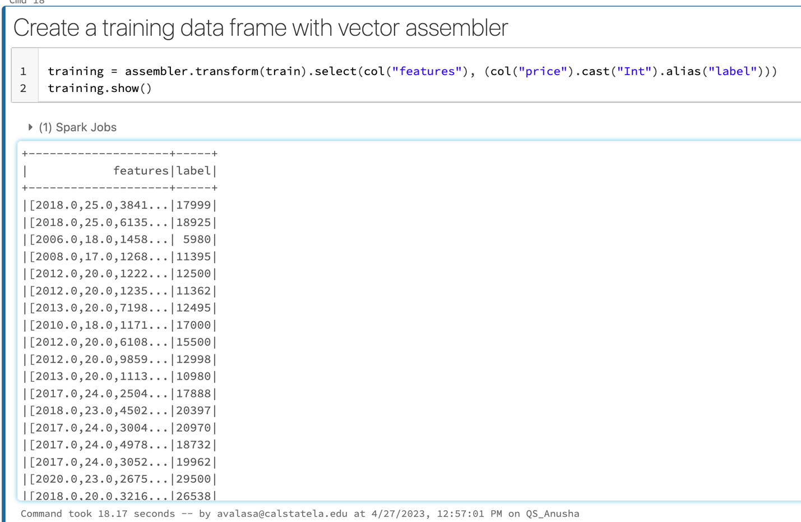

**3)Train a Regression Model**

lr = LinearRegression(labelCol="label",featuresCol="features", maxIter=10, regParam=0.3)

model = lr.fit(training)

print("Model trained!")

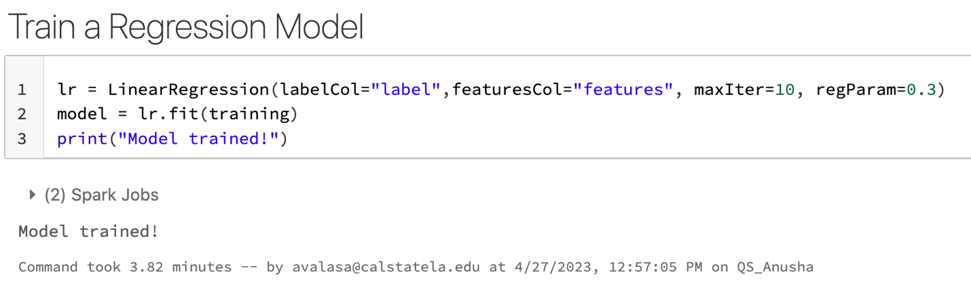

**4)Prepare the Testing Data to transform the test data into a feature and a label.**

testing = assembler.transform(test).select(col("features"), col("price").cast("Int").alias("trueLabel"))

testing.show()

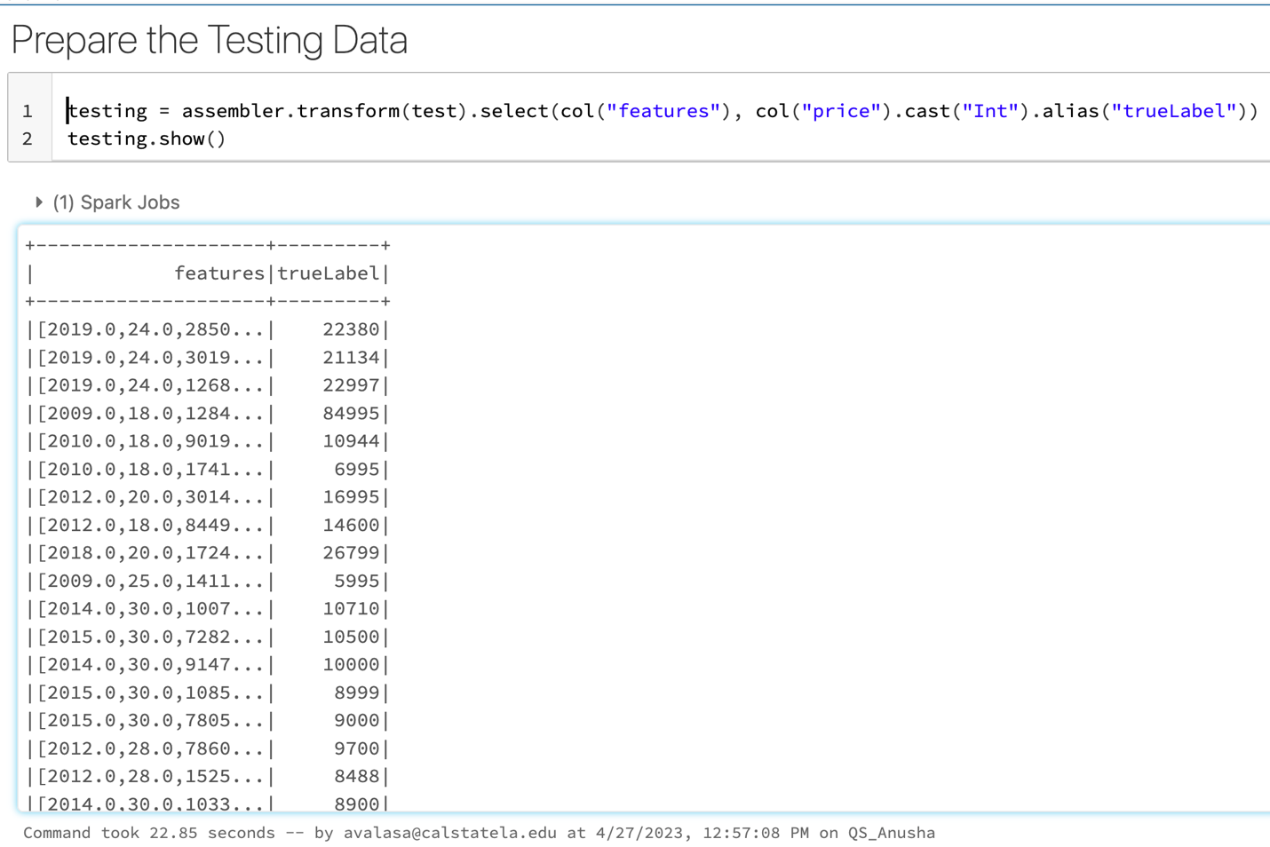

**5)It runs the testing data frame on the model that we built. Then, the**

**models predict the value “prediction,” that is, how to predict the price of the car. It can be compared to “true label”:**

prediction = model.transform(testing)

# does not need probability parameter of Logistic Regression

predicted = prediction.select("features", col("prediction").cast("Int"), "trueLabel")

predicted.show()

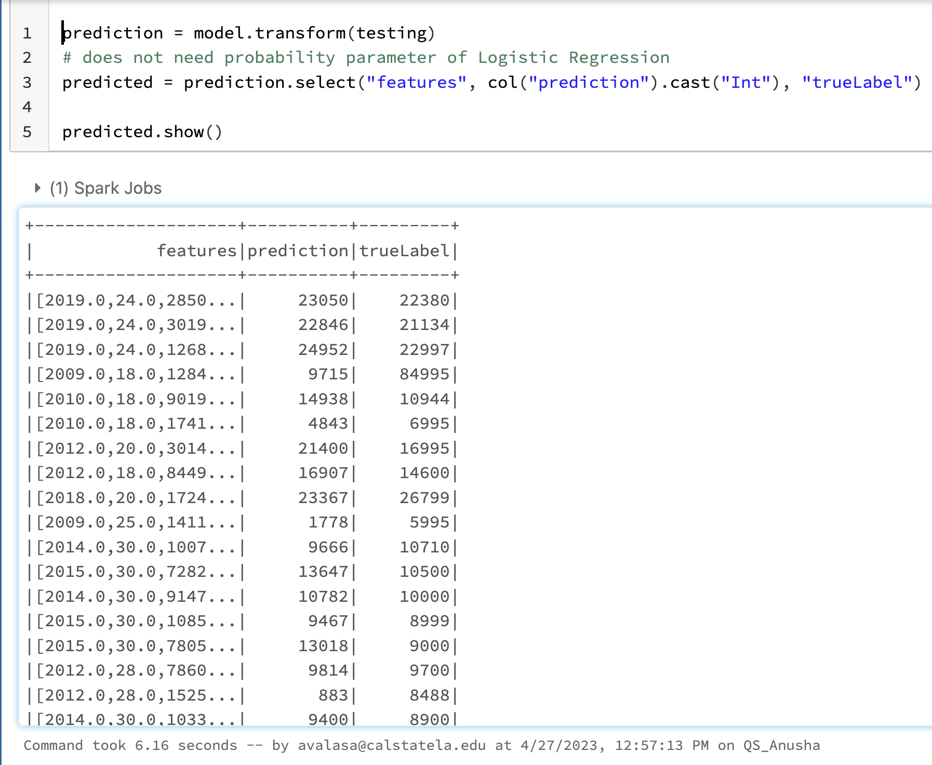

6)**Run the following code in a separate cell, To compare the columns in the scatter chart: trueLabel and Prediction.**

display(predicted)

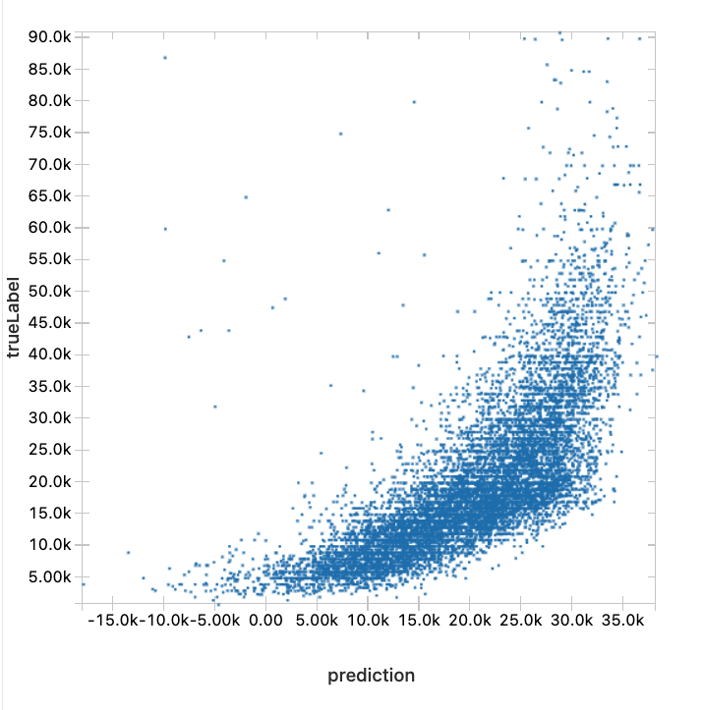

**7)Run the following code at a new cell to evaluate the model built with the training data:**

trainingSummary = model.summary

print("RMSE: %f" % trainingSummary.rootMeanSquaredError)

print("r2: %f" % trainingSummary.r2)

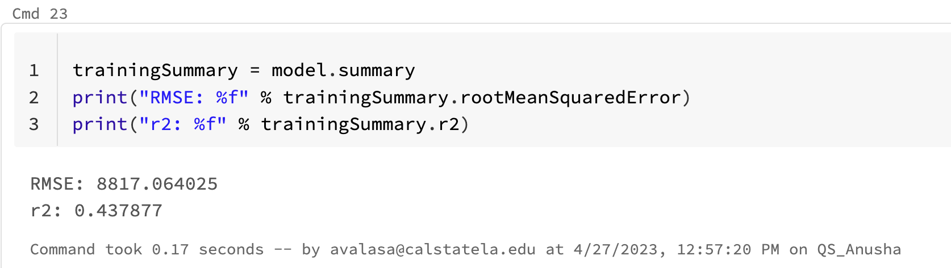

8)**Run the following code at a new cell to evaluate the prediction result of the model with the test data:**

from pyspark.ml.evaluation import RegressionEvaluator

lr_evaluator = RegressionEvaluator(predictionCol="prediction", \

labelCol="trueLabel",metricName="r2")

print("R Squared (R2) on test data = %g" %

lr_evaluator.evaluate(prediction))

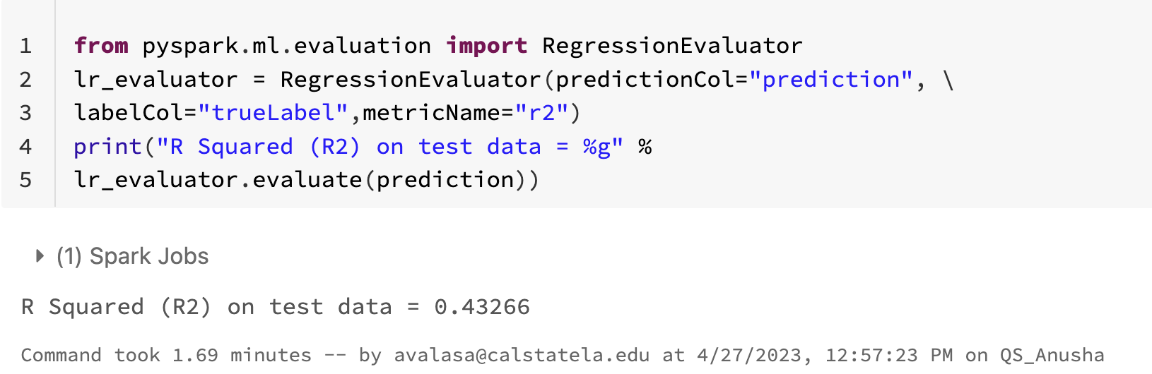

**Result:**

**Coefficient R2 is far from 1, which means the model is inaccurate.**

**Algorithm 2: Gradient Boost Tree(GBT)**

**1)Create a vector assembler with input columns and name it as gbt_assembler**

gbt_assembler = VectorAssembler(inputCols = ["year", "city_fuel_economy", "mileage", "owner_count", "highway_fuel_economy"], outputCol="features").setHandleInvalid("skip")

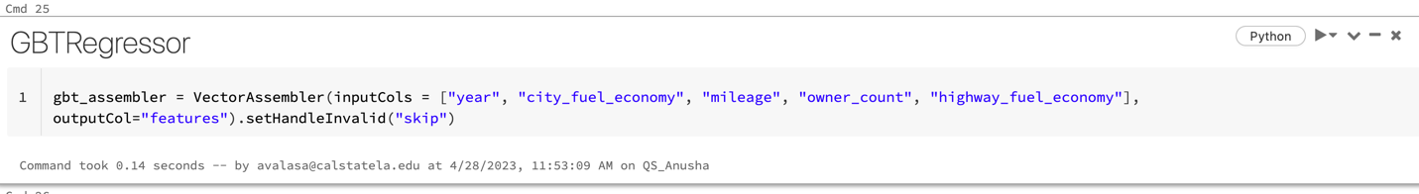

**2)Create a training data frame for GBT**

training = gbt_assembler.transform(train)

training.show()

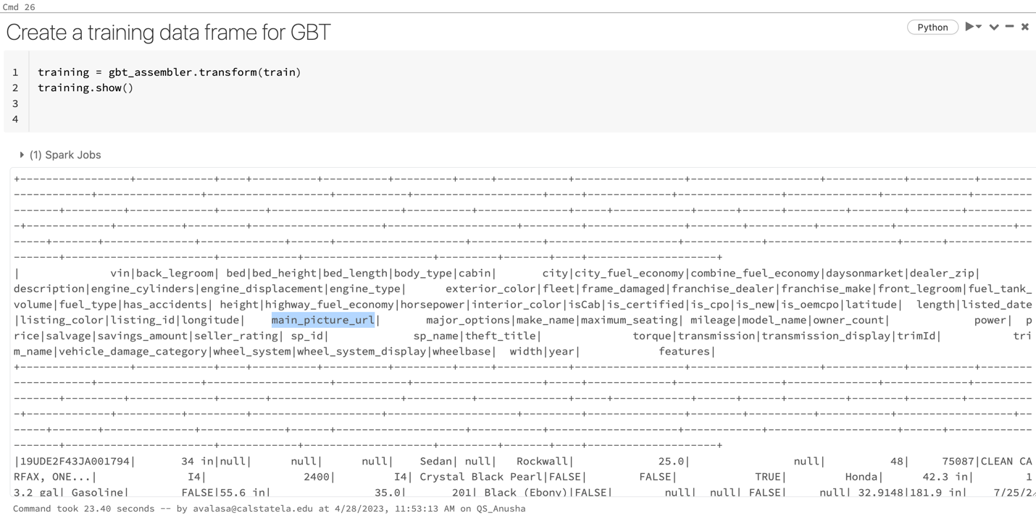

**3)Setup a model with GBTRegressor**

gbt = GBTRegressor(labelCol="price") #,featuresCol="features",maxIter=10

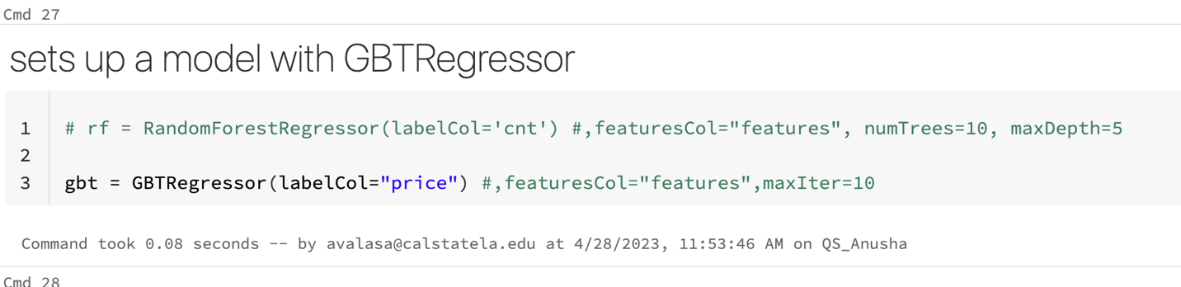

**4)Create a parameter combination, which is to tune the model, It has a grid of hyperparameters to test the possible models with the combination of max depth and maxIter**

paramGrid = ParamGridBuilder()\

.addGrid(gbt.maxDepth, [2, 5])\

.addGrid(gbt.maxIter, [10, 20])\

.build()

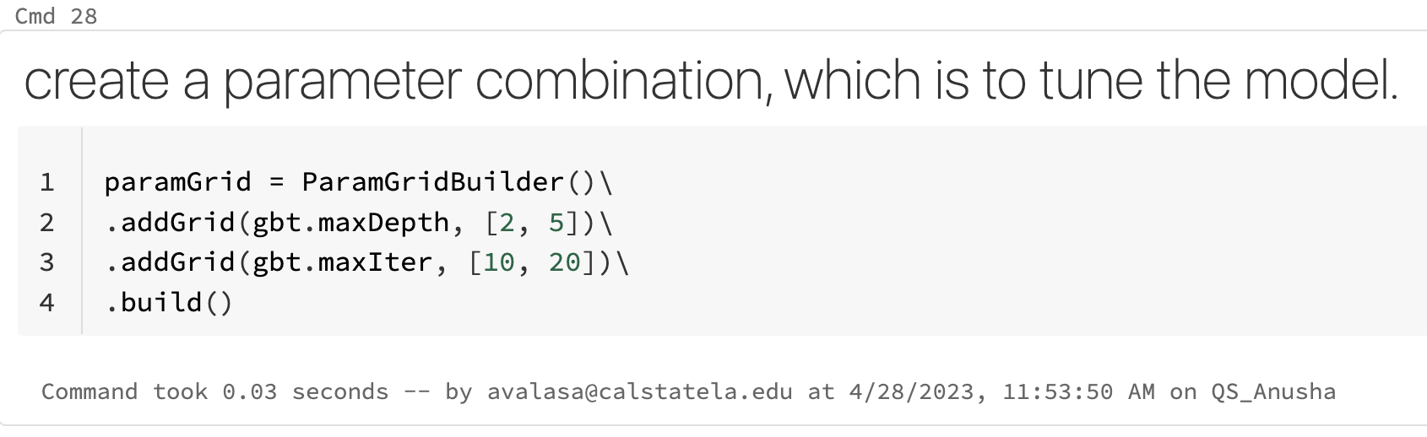

**5)Create a evaluator to evaluate a model with R2**

from pyspark.ml.evaluation import RegressionEvaluator

gbt_evaluator = RegressionEvaluator(predictionCol="prediction", \

labelCol="price",metricName="r2")

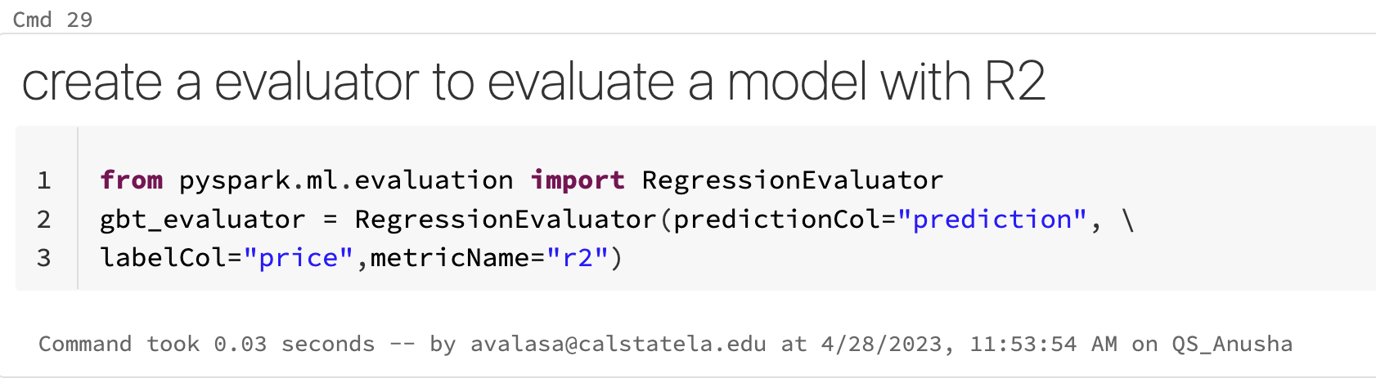

**Create a pipeline, which is to sequence the tasks.**

pipeline = Pipeline(stages=[gbt_assembler, gbt])

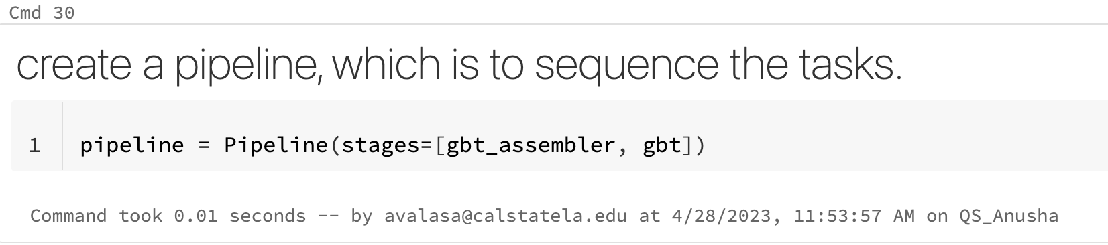

**6)Create a cross-validator to tune the model for the generalization. The default folds are 3.**

cv = CrossValidator(estimator=pipeline, evaluator=gbt_evaluator, estimatorParamMaps=paramGrid)

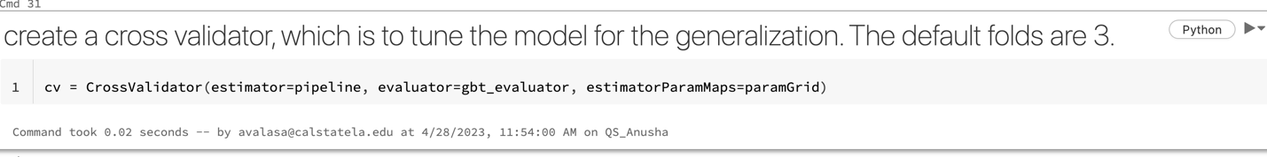

**7)Build a model with the train data frame**

model = cv.fit(train)

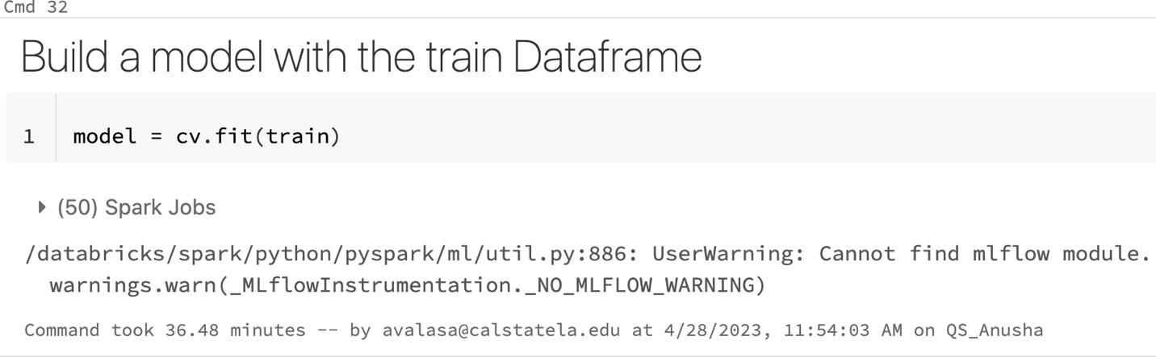

**8)Calculate the feature importance of the GBT algorithm**

prediction = model.transform(test)

predicted = prediction.select("features", "prediction", "price")

predicted.show()

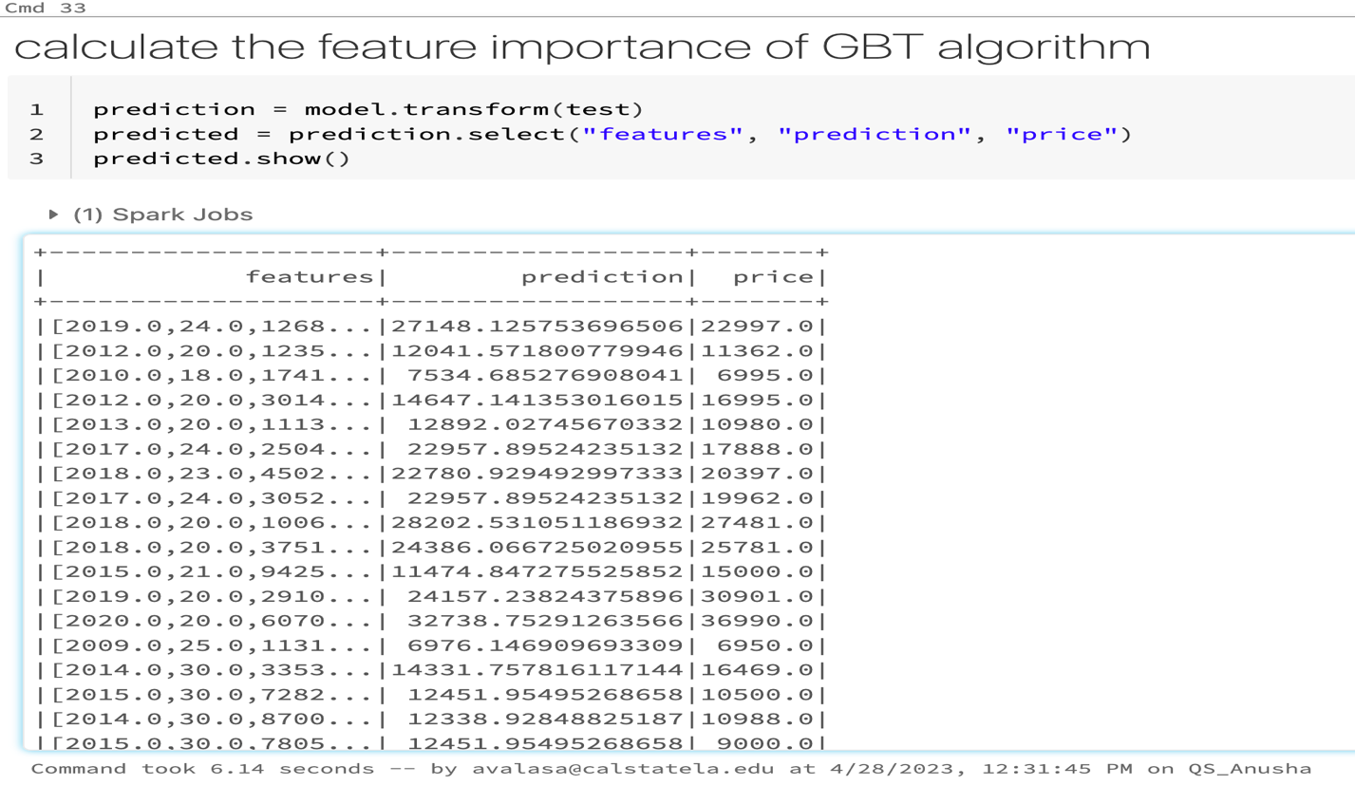

**9)To display the Visualization for us used car predicted price vs. actual price**

display(predicted)

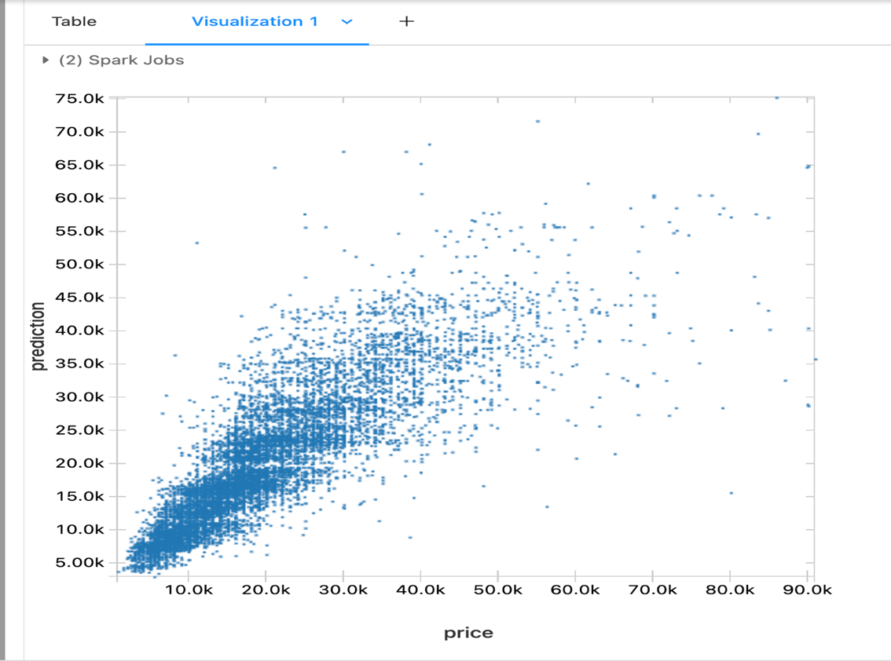

**10)To evaluate the prediction result R2 (Coefficient of Determination) and RMSE of the model with the test data:**

print("R Squared (R2) on test data = %g" % gbt_evaluator.evaluate(prediction))

gbt_evaluator = RegressionEvaluator(labelCol="price",predictionCol="prediction", metricName="rmse")

print("RMSE: %f" % gbt_evaluator.evaluate(prediction))

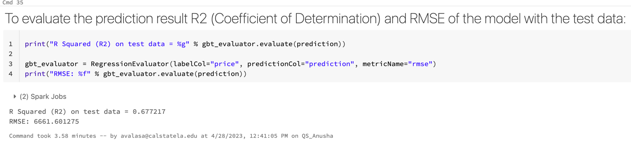

**11)You observe that the coefficient, R2, is 0.675, which is not much closer to 1, compared to the linear Regression: RMSE is 6728.73 In the previous model, we had : [R2: 0.436939, RMSE: 8837.227827]**

from pyspark.ml.evaluation import RegressionEvaluator

gbt_evaluator1 = RegressionEvaluator(predictionCol="prediction", \

labelCol="price",metricName="r2")

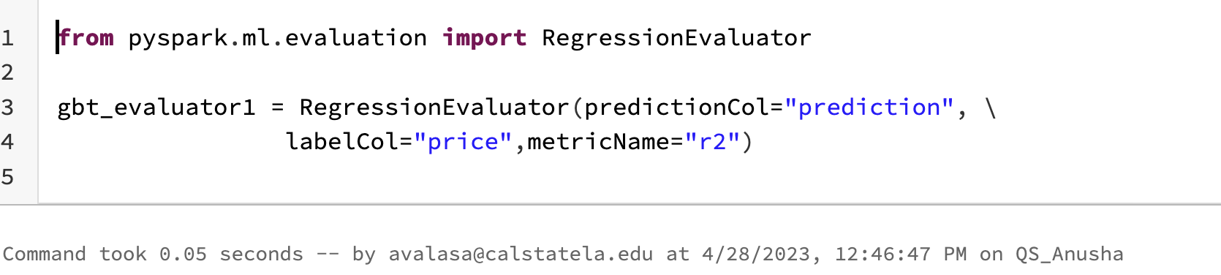

**12)Use TrainValidationSplit instead of CrossValidator**

cv1 = TrainValidationSplit(estimator=pipeline, evaluator=gbt_evaluator1, estimatorParamMaps=paramGrid, trainRatio=0.8)

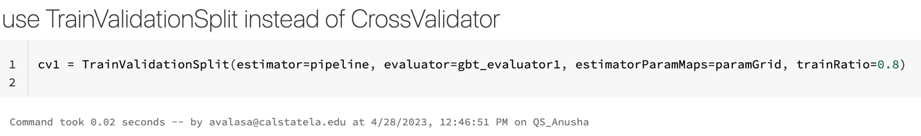

**13)Build a model with the train Dataframe of Train Validation Split**

model1 = cv1.fit(train)

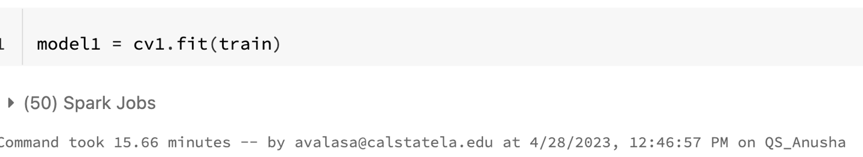

**14)Calculate the feature importance of the GBT algorithm using TrainValidationSplit**

prediction = model1.transform(test)

predicted = prediction.select("features", "prediction", "price")

predicted.show()

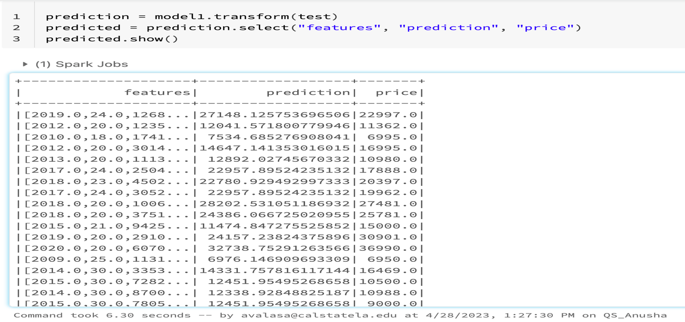

**15)To compare the columns in the scatter chart: price and Prediction.**

display(predicted)

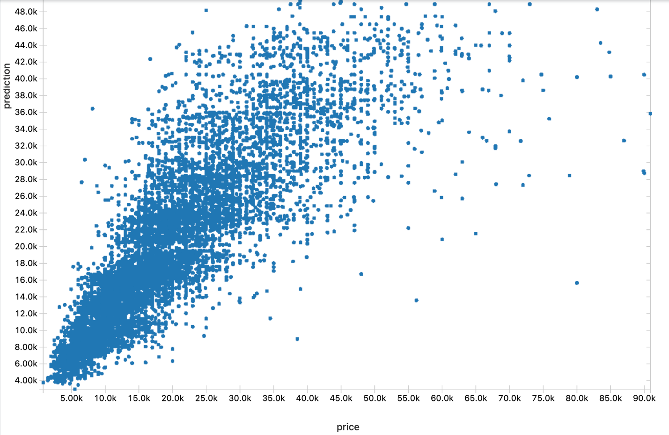

**16)To evaluate the prediction result R2 (Coefficient of Determination) and RMSE of the model with the test data:**

print("R Squared (R2) on test data = %g" % gbt_evaluator1.evaluate(prediction))

gbt_evaluator = RegressionEvaluator(labelCol="price", predictionCol="prediction", metricName="rmse")

print("RMSE: %f" % gbt_evaluator.evaluate(prediction))

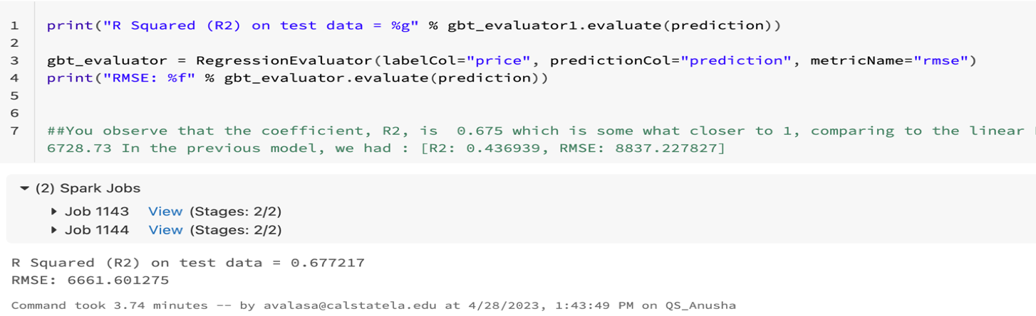

**RESULT NOTE:**

You observe that the coefficient, R2, is 0.677 and RMSE is 6661.601 In the

Previous model, we have [R2: 0.675, RMSE: 6728.73], the same as in CrossValidator; TrainValidationSplit has a similar generalization, but TrainValidationSplit is much faster than CrossValidator.

**The coefficient r2 is 0.6, somewhat closer compared to the linear regression r2 0.4**

**Algorithm 3: Random Forest Regressor**

**1)Random Forest Regressor**

assembler = VectorAssembler(inputCols = ["year", "city_fuel_economy", "mileage", "owner_count", "highway_fuel_economy"], outputCol="features").setHandleInvalid("skip")

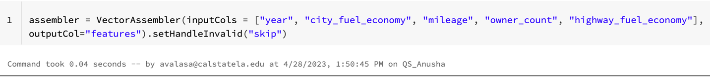

**2)Create a training data frame for Random Forest Regressor**

training = assembler.transform(train)

training.show()

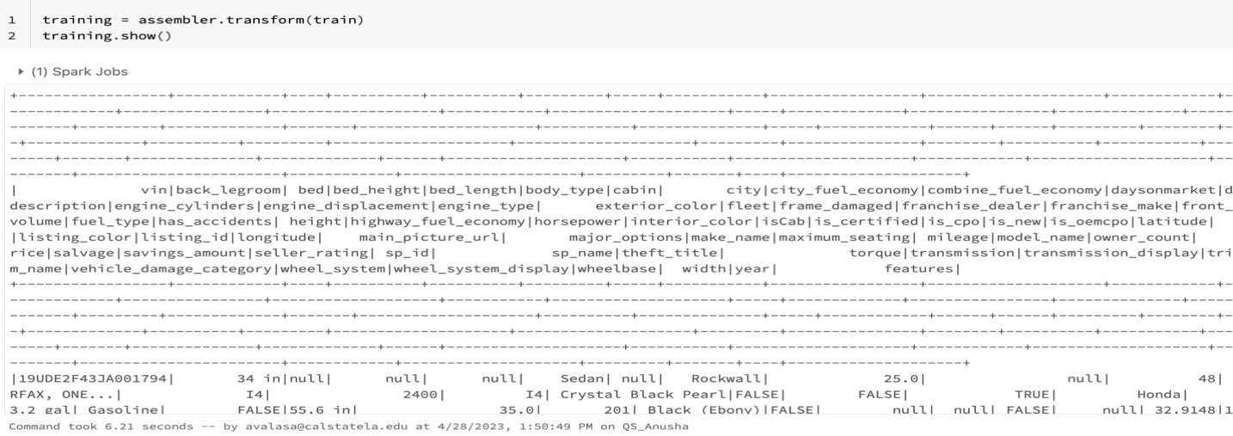

**3)Set up a model with Random Forest Regressor**

rf = RandomForestRegressor(labelCol='price') #,featuresCol="features", numTrees=10, maxDepth=5

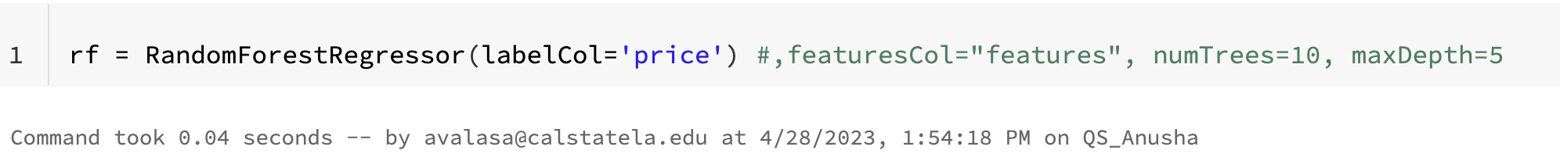

**4)create a pipeline, which is to sequence the tasks.**

pipeline = Pipeline(stages=[assembler, rf])

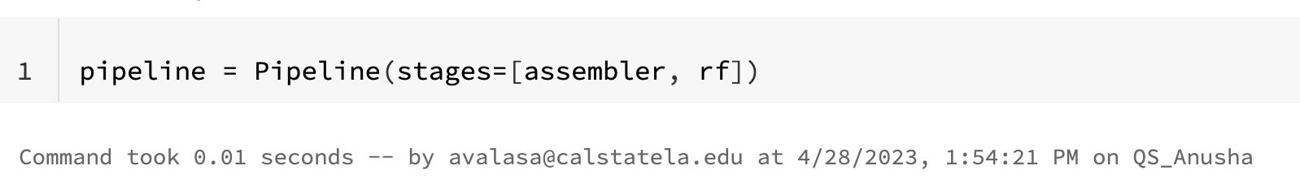

**5)Tune the model for the generalization.**

model = pipeline.fit(train)

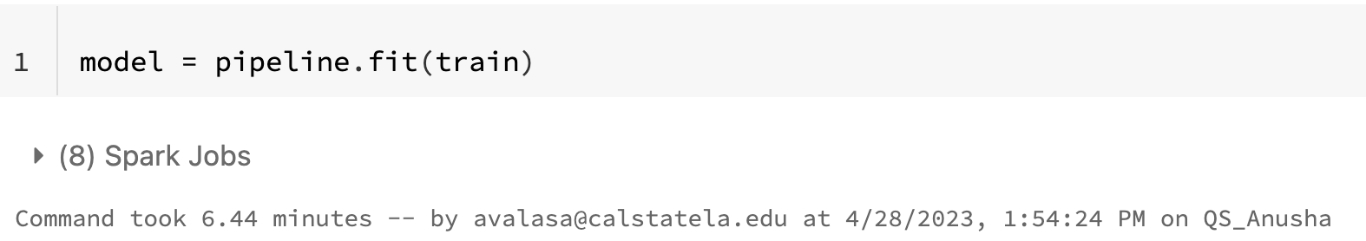

**6)Build a model with the train Dataframe**

rfModel = model.stages[-1]

print(rfModel.toDebugString)

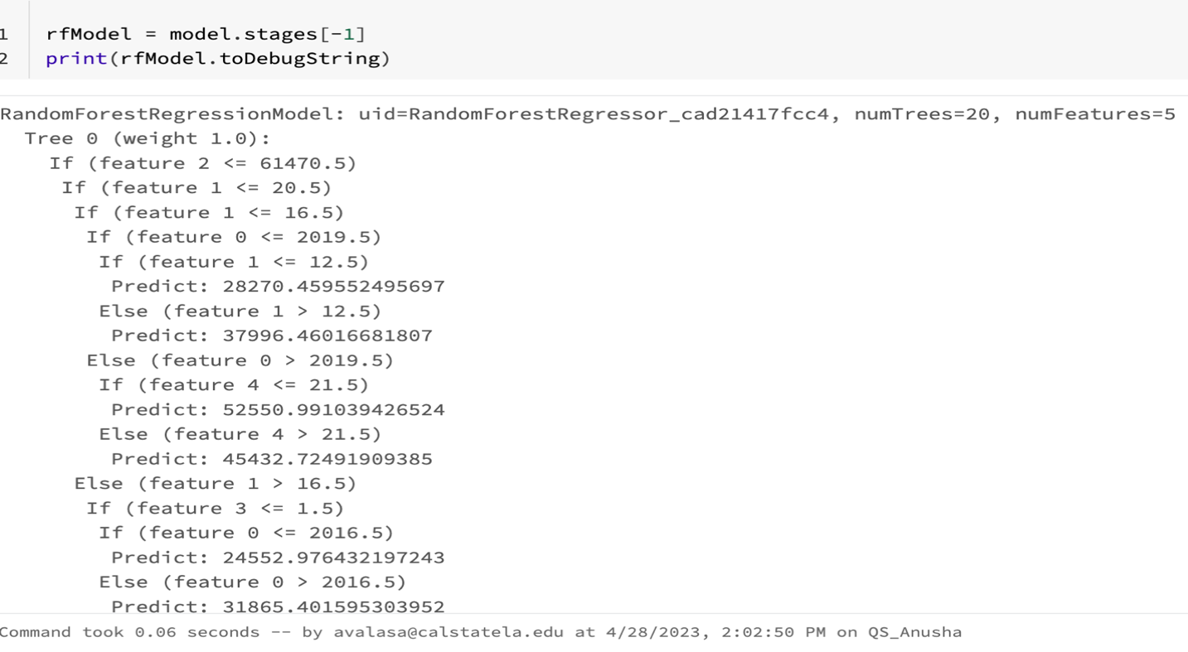

**7)Show the importance of the features – columns – in the order of importance. NOTE: this code uses the pandas' library in standard Python, not in PySpark.**

import pandas as pd

featureImp = pd.DataFrame(list(zip(assembler.getInputCols(), rfModel.featureImportances)), columns=["feature", "importance"])

featureImp.sort_values(by="importance", ascending="False")

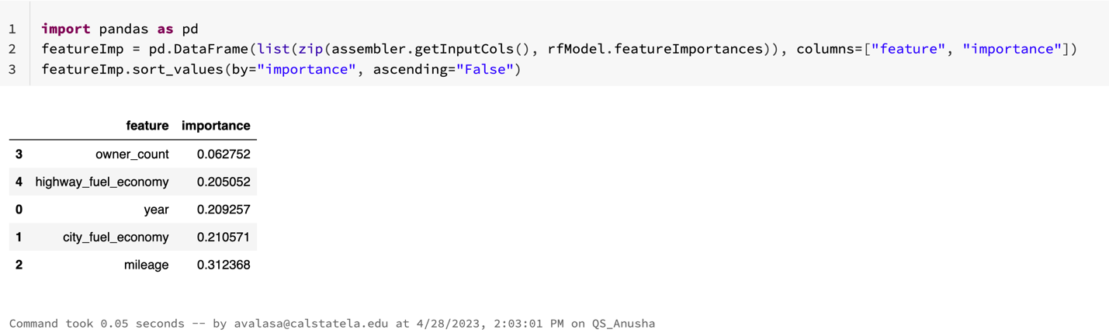

**8)Build an RF model using pipeline with the paramters (numTrees=10, maxDepth=5) and train data set.**

rf = RandomForestRegressor(labelCol="price", featuresCol="features", numTrees=10, maxDepth=5)

# combine stages into pipeline

pipeline = Pipeline(stages= [assembler, rf])

model = pipeline.fit(train)

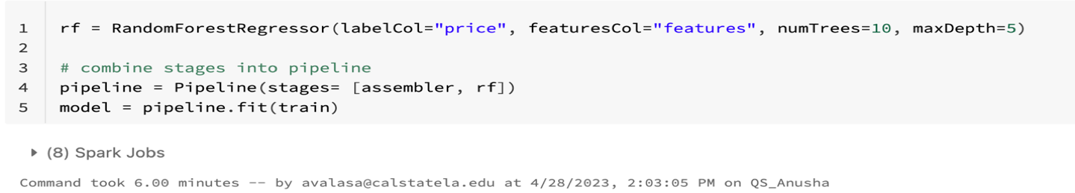

**9)To see the following info**

display(test)

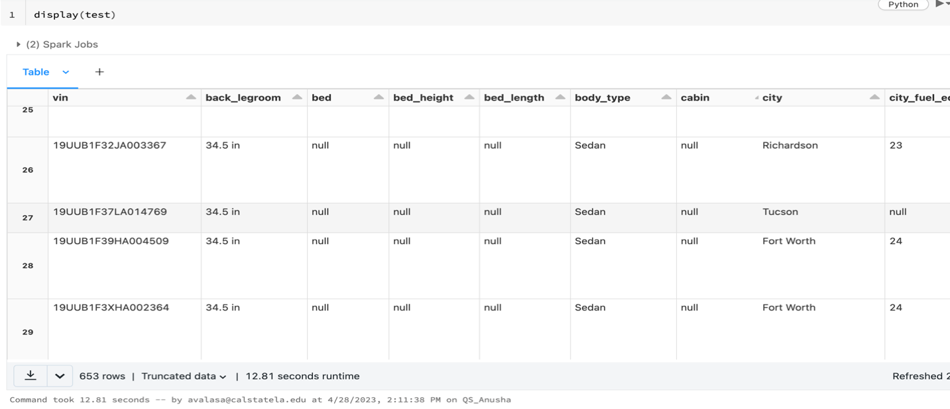

**10)Testing data frame on the model that we built. Then, the model predicts the value “prediction” that the price of used cars counts. It can be compared to “price” in the target column, the actual price of the used cars.**

prediction = model.transform(test)

predicted = prediction.select("features", "prediction", "price")

predicted.show()

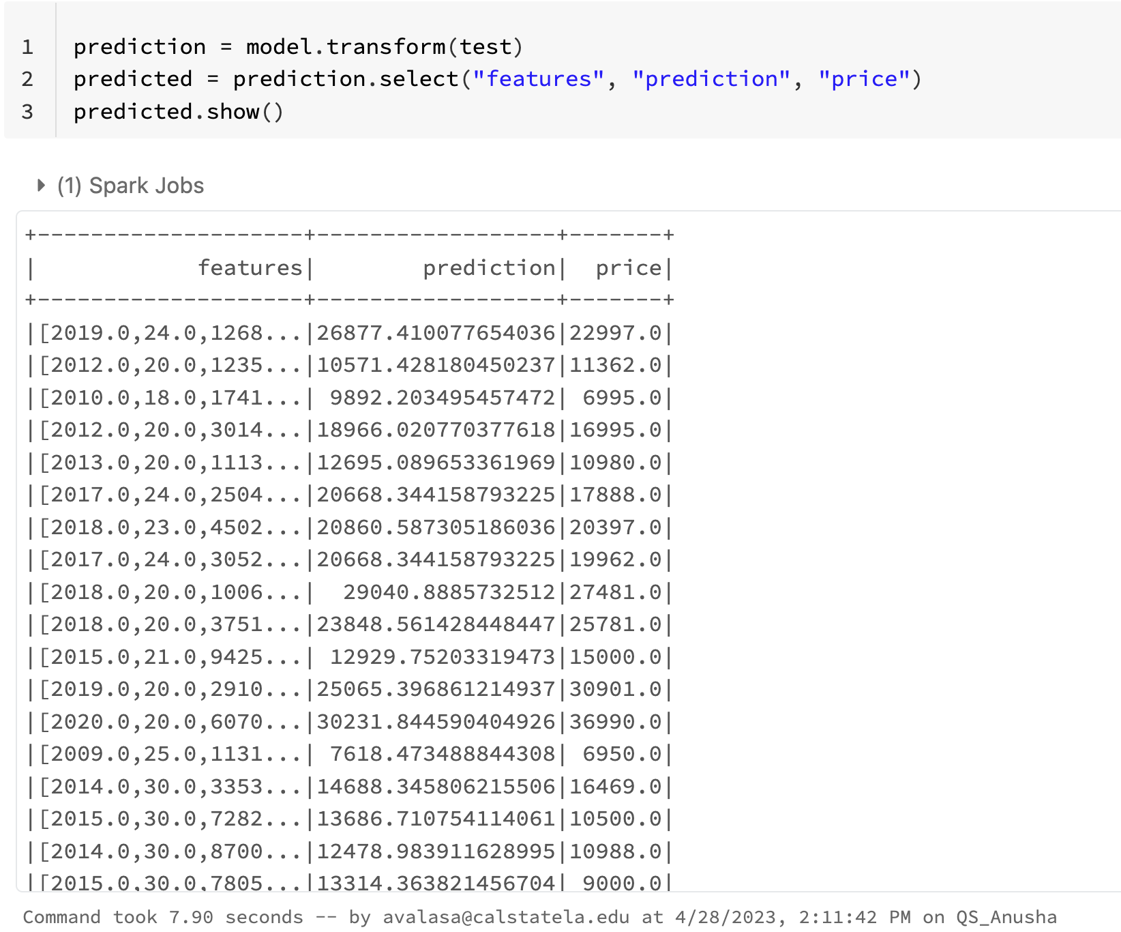

**11)To compare the columns in the scatter chart: price and Prediction.**

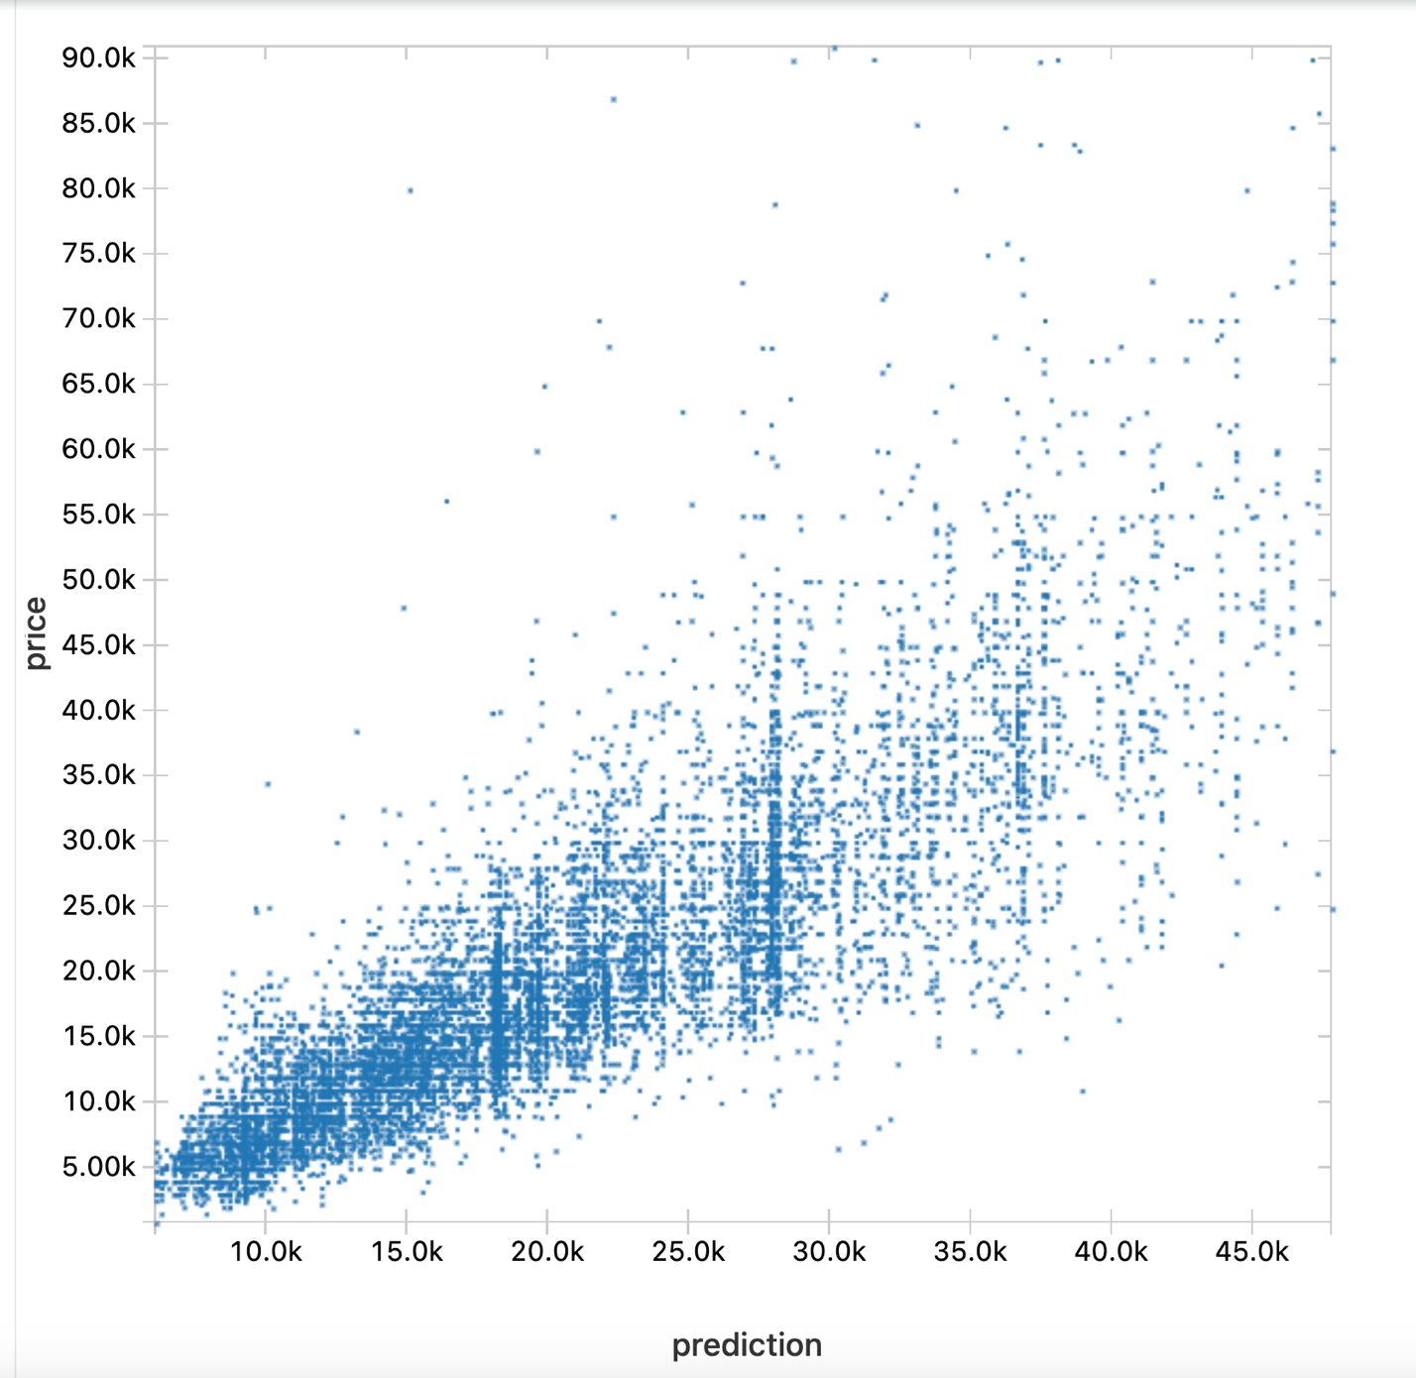

**12)Evaluate the prediction result of the model with the test data:**

from pyspark.ml.evaluation import RegressionEvaluator

rf_evaluator = RegressionEvaluator(predictionCol="prediction", \

labelCol="price",metricName="r2")

print("R Squared (R2) on test data = %g" % rf_evaluator.evaluate(prediction))

rf_evaluator = RegressionEvaluator(labelCol="price", predictionCol="prediction", metricName="rmse")

print("RMSE: %f" % rf_evaluator.evaluate(prediction)

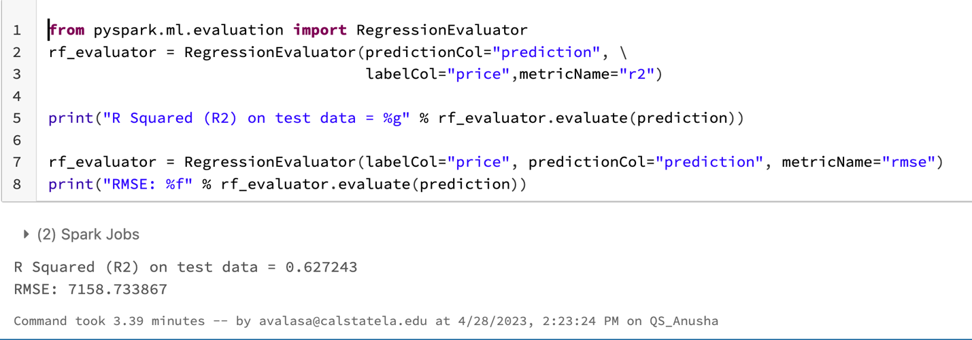

**Algorithm 3: Decision Tree Classifier**

**1)Decision Tree Classifier**

**f**lightSchema = StructType([

StructField("year", IntegerType(), False),

StructField("price", IntegerType(), False),

StructField("mileage", StringType(), False),

StructField("owner_count", IntegerType(), False),

StructField("seller_rating", IntegerType(), False),

StructField("city_fuel_economy", IntegerType(), False),

StructField("highway_fuel_economy", IntegerType(), False),

])

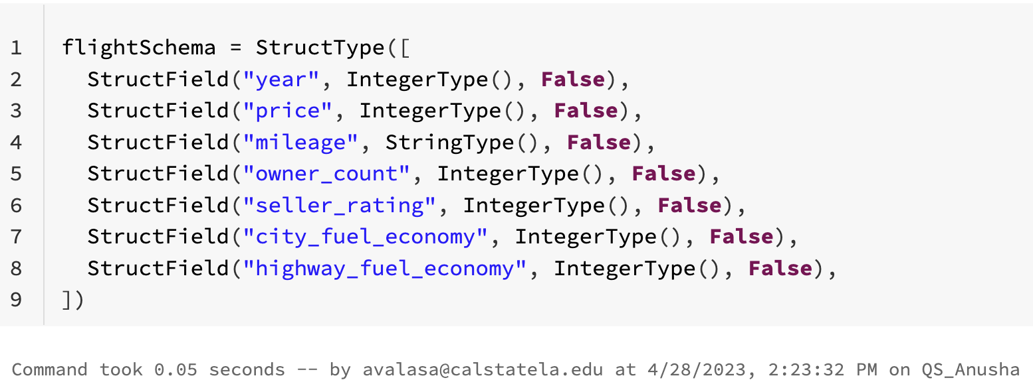

**2)To display the selected columns**

display(df2.select("year", "city_fuel_economy", col("price").alias("label"), "mileage", "owner_count", "latitude", "highway_fuel_economy"))

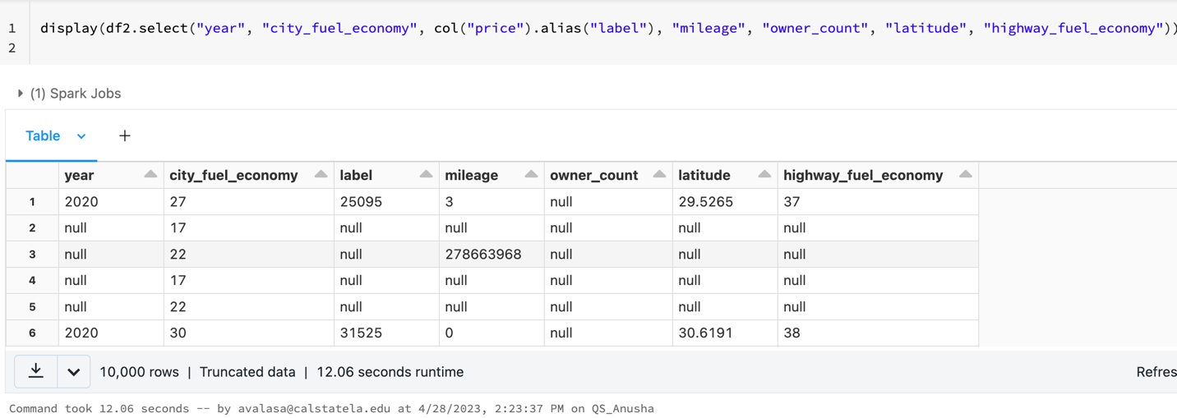

**3)** **Data Conversion and Data Filtering**

df2 = df2.filter(col("price") < 100000)

display(df2)

df23 = df2.select("year", "city_fuel_economy", ((col("price") > 10000).cast("Double").alias("label")), "mileage", "owner_count", "highway_fuel_economy")

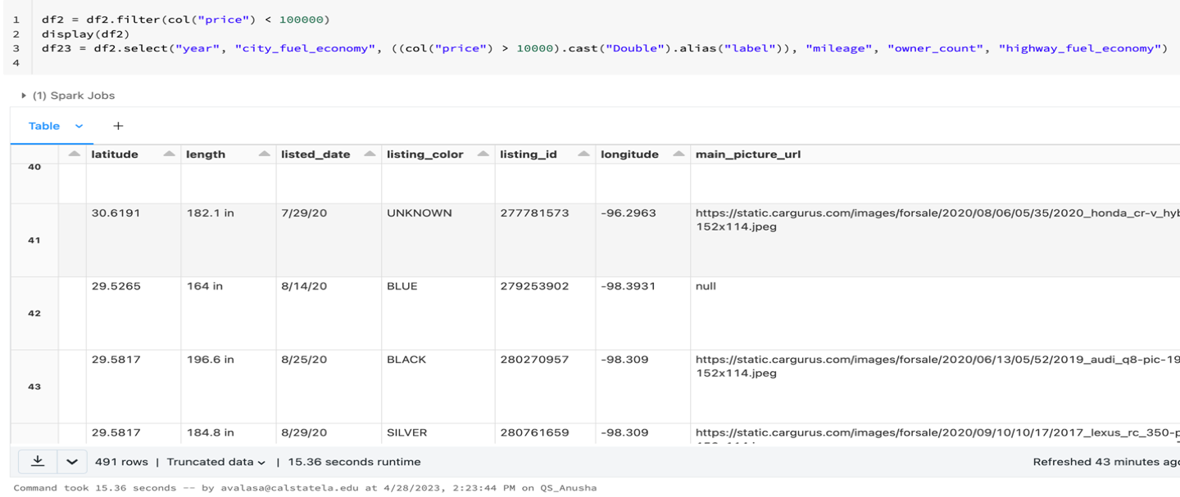

**4) Drop the Unused Columns**

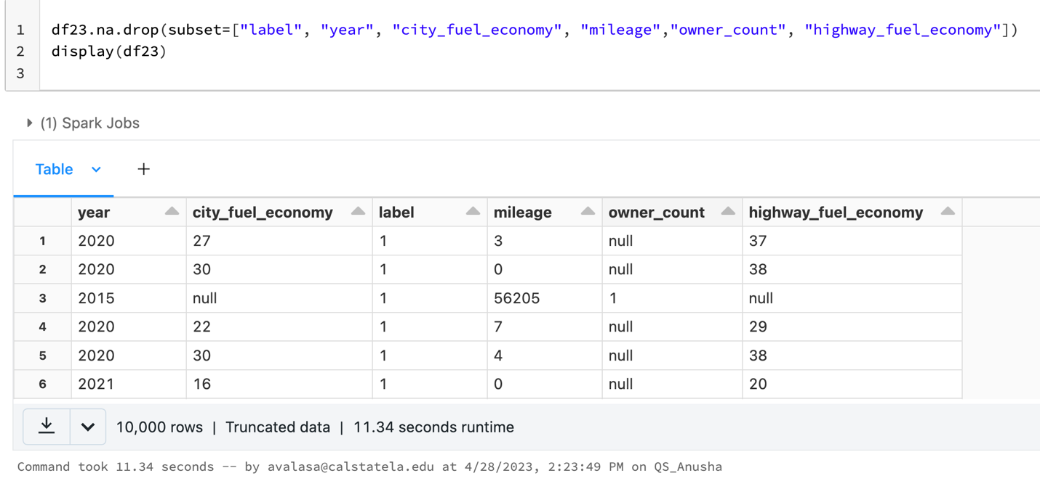

**5)** **Split the Data**

splits = df23.randomSplit([0.7, 0.3])

train = splits[0]

test = splits[1].withColumnRenamed("label", "trueLabel")

train_rows = train.count()

test_rows = test.count()

print("Training Rows:", train_rows, " Testing Rows:", test_rows)

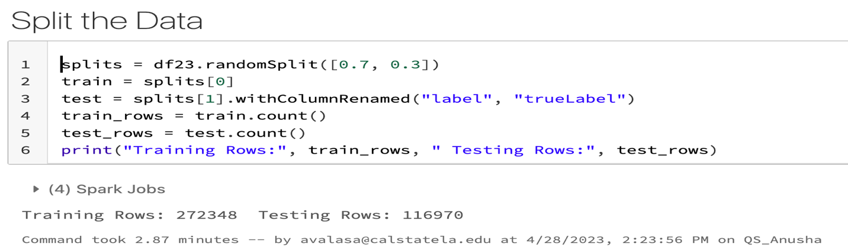

**6)The following columns are categorical numbers, so it should be Category features.**

catVect = VectorAssembler(inputCols = ["mileage", "owner_count", "city_fuel_economy", "highway_fuel_economy"], outputCol="catFeatures").setHandleInvalid("skip")

catIdx = VectorIndexer(inputCol = catVect.getOutputCol(), outputCol = "idxCatFeatures").setHandleInvalid("skip")

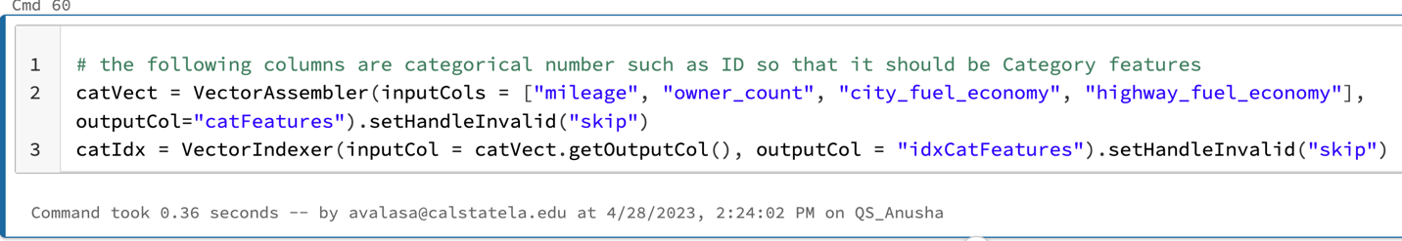

# number is meaningful so that it should be number features

numVect = VectorAssembler(inputCols = ["year"], outputCol="numFeatures")

# number vector is normalized

minMax = MinMaxScaler(inputCol = numVect.getOutputCol(), outputCol="normFeatures")

featVect = VectorAssembler(inputCols=["idxCatFeatures", "normFeatures"], outputCol="features") #="features1")

# number vector is normalized: this changes the accuracy of precision a little

# minMax2 = MinMaxScaler(inputCol = featVect.getOutputCol(), outputCol="features")

#dt = DecisionTreeClassifier(labelCol="label", featuresCol="features")

lr = LogisticRegression(labelCol="label",featuresCol="features",maxIter=10,regParam=0.3)

# Pipeline process the series of transformation above, which is 7 transformation

pipeline = Pipeline(stages=[catVect, catIdx, numVect, minMax, featVect, lr]) #minMax2, lr])

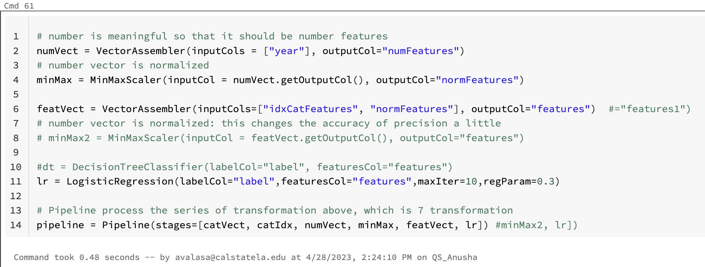

**7)Tune Parameters**

paramGrid = (ParamGridBuilder() \

.addGrid(lr.regParam, [0.01, 0.5]) \

.addGrid(lr.elasticNetParam, [0.0, 0.5]) \

.addGrid(lr.maxIter, [1, 5]) \

.build())

#paramGrid = ParamGridBuilder().addGrid(lr.regParam, [0.3, 0.1, 0.01]).addGrid(lr.maxIter, [10, 5]).addGrid(lr.threshold, [0.35, 0.30]).build()

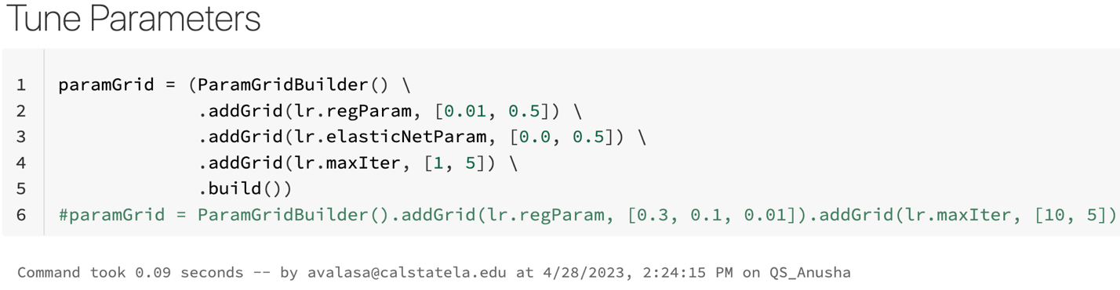

**8)CrossValidator vs TrainValidationSplit**

cv = TrainValidationSplit(estimator=pipeline, evaluator=BinaryClassificationEvaluator(), estimatorParamMaps=paramGrid, trainRatio=0.8)

model = cv.fit(train)

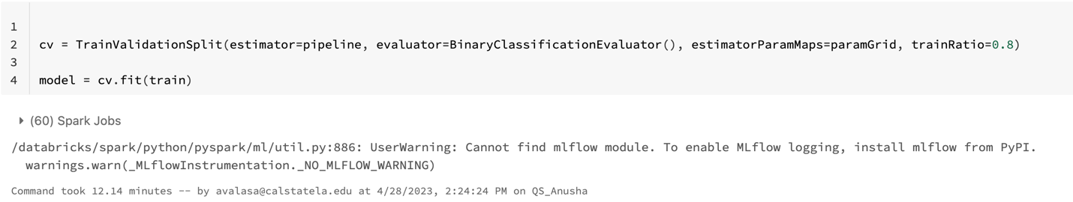

**9)Test the Pipeline Model (The model produced by the pipeline is a transformer that will apply all of the stages in the pipeline to a specified DataFrame and apply the trained model to generate predictions. In this case, you will transform the test DataFrame using the pipeline to generate label predictions.)**

prediction = model.transform(test)

predicted = prediction.select("features", "prediction", "probability", "trueLabel")

predicted.show(100, truncate=False)

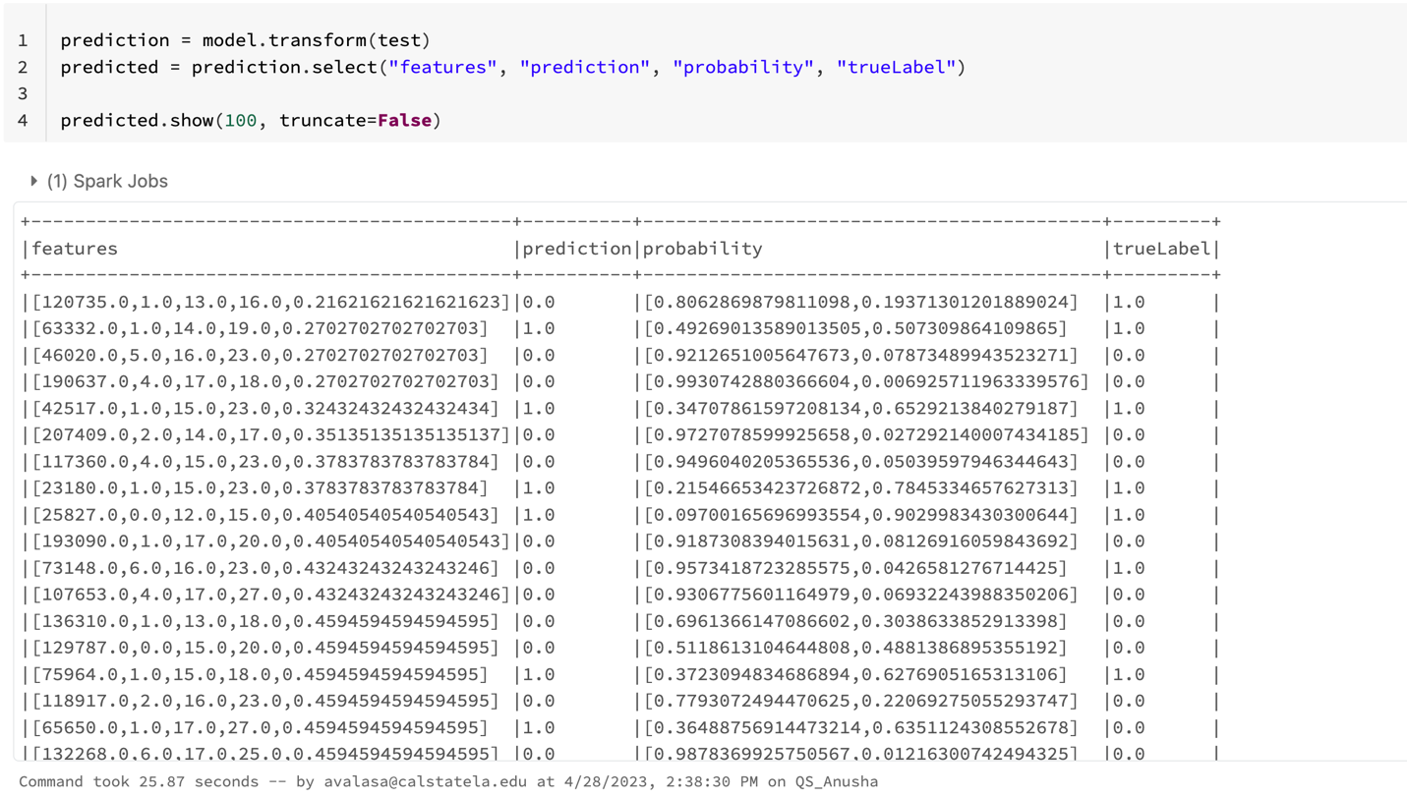

**10)Compute Confusion Matrix Metrics Classifiers are typically evaluated by creating a confusion matrix, which indicates the number of: True Positives True Negatives False Positives False Negatives From these core measures, other evaluation metrics such as precision and recall can be calculated.**

tp = float(predicted.filter("prediction == 1.0 AND truelabel == 1").count())

fp = float(predicted.filter("prediction == 1.0 AND truelabel == 0").count())

tn = float(predicted.filter("prediction == 0.0 AND truelabel == 0").count())

fn = float(predicted.filter("prediction == 0.0 AND truelabel == 1").count())

metrics = spark.createDataFrame([

("TP", tp),

("FP", fp),

("TN", tn),

("FN", fn),

("Precision", tp / (tp + fp)),

("Recall", tp / (tp + fn))],["metric", "value"])

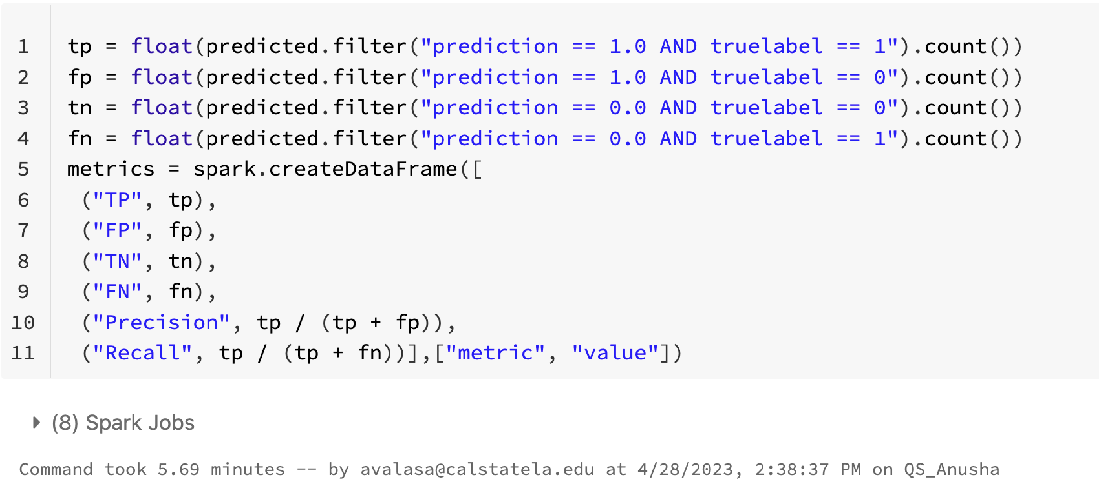

**metrics.show()**

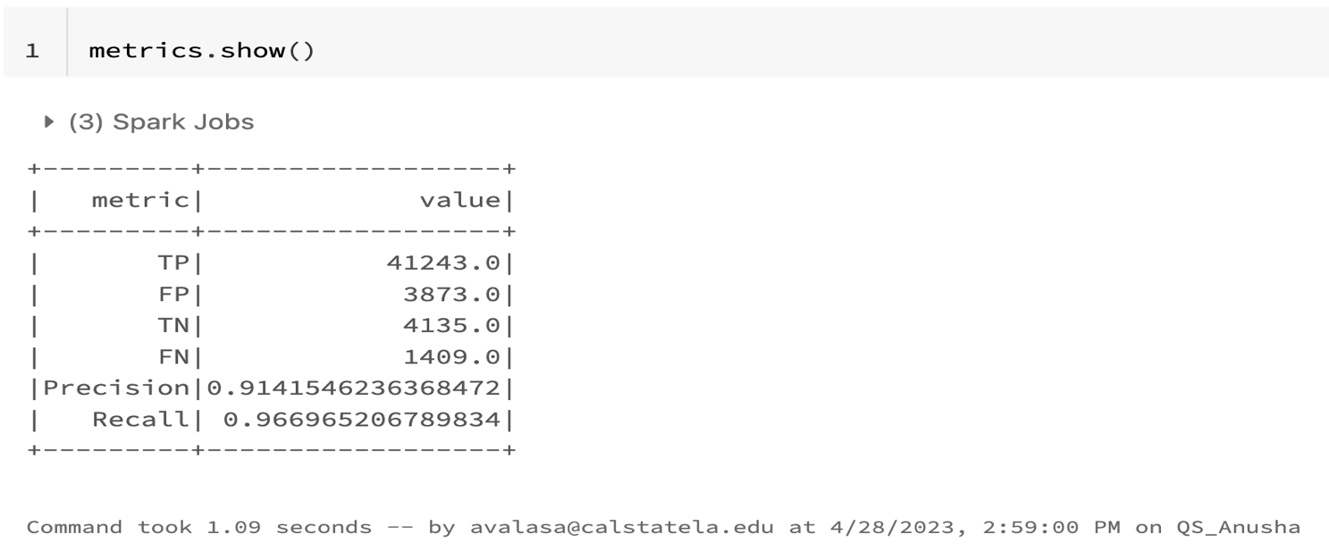

**12)View the Raw Prediction and Probability The prediction is based on a raw prediction score that describes a labeled point in a logistic function. This raw prediction is then converted to a predicted label of 0 or 1 based on a probability vector that indicates the confidence for each possible label value (in this case, 0 and 1). The value with the highest confidence is selected as the prediction.**

prediction.select("rawPrediction", "probability", "prediction", "trueLabel").show(100, truncate=False)

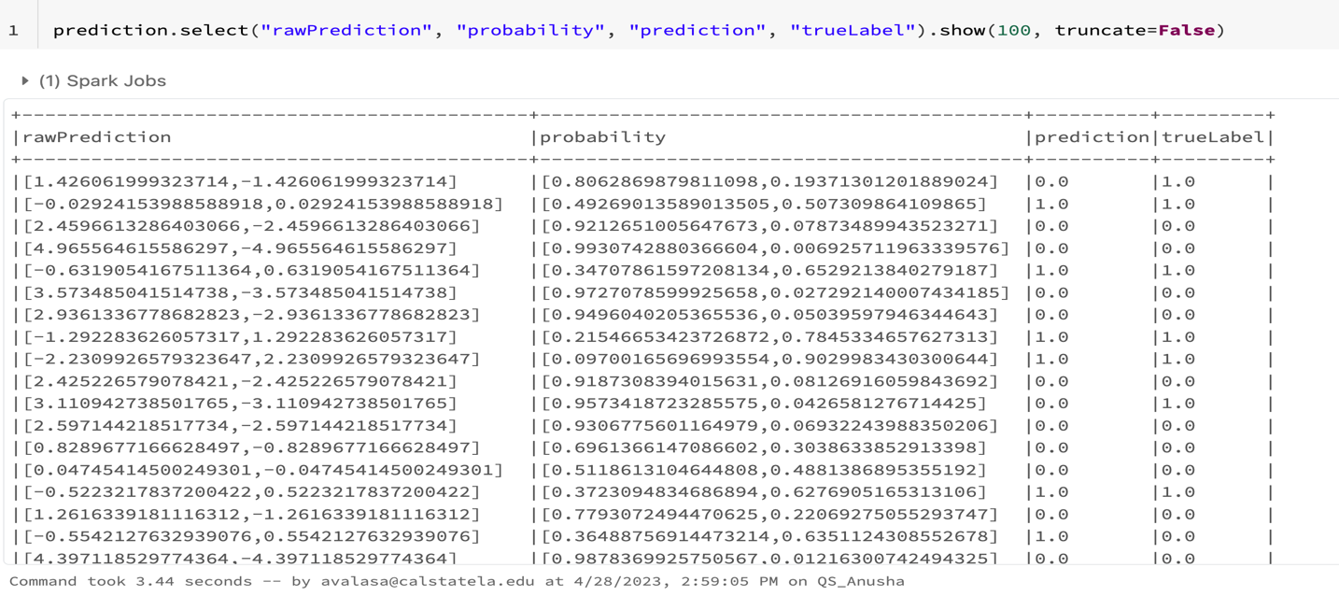

Note that there are now more True Positives and less False Negatives, and Recall has improved. By changing the discrimination threshold, the model gets more predictions correct - though it’s worth noting that the number of False Positives has also increased. Calculate the updated AUC.

**13)Review the Area Under ROC Another way to assess the performance of a classification model is to measure the area under a ROC curve for the model. the spark.ml library includes a BinaryClassificationEvaluator class that you can use to compute this. The ROC curve shows the True Positive and False Positive rates plotted for varying thresholds. AUC is very high if it is 0.94035 (=94%).**

evaluator = BinaryClassificationEvaluator(labelCol="trueLabel", rawPredictionCol="rawPrediction", metricName="areaUnderROC")

auc = evaluator.evaluate(prediction)

print("AUC = ", auc)

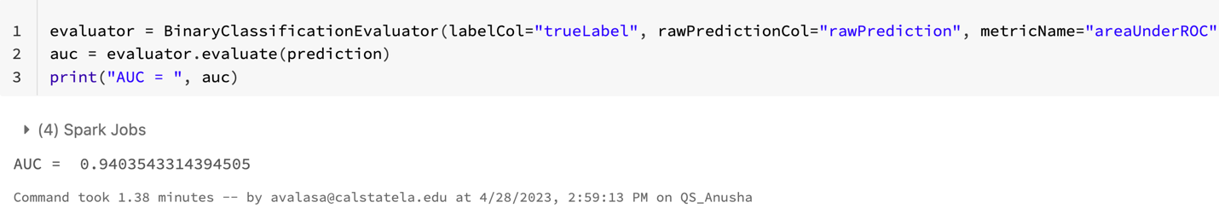

**To run the whole 9.9 GB used_cars_data_set.csv with Pyspark Submit.**

Download .py file from the Databricks

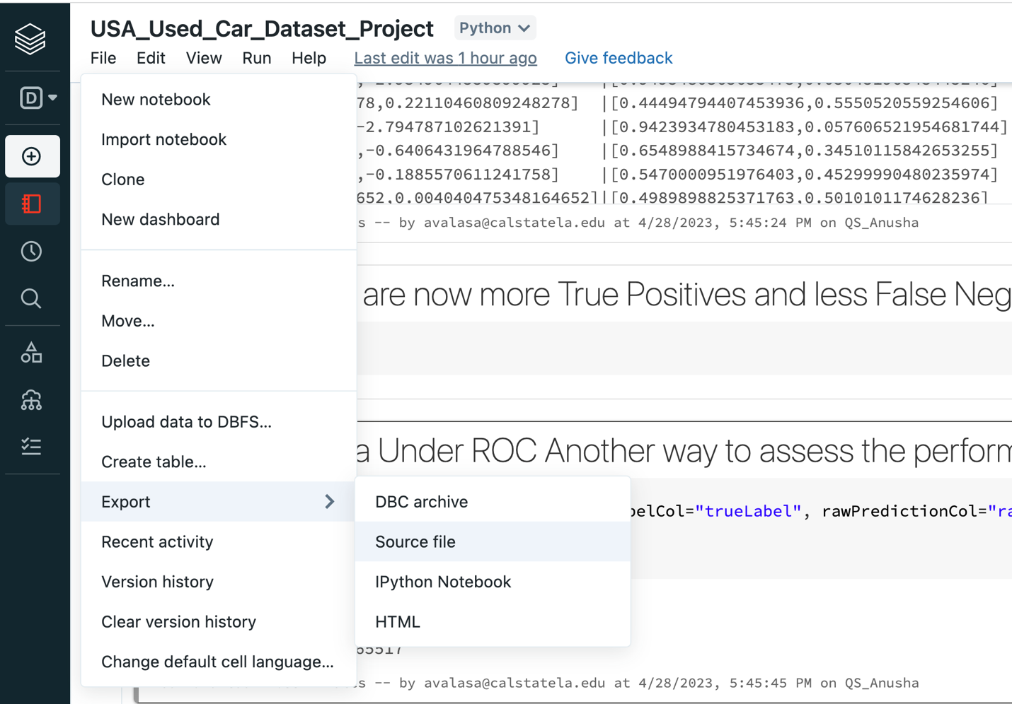

**PYSPARK SUBMIT**

**STEP 1:** Connect to the Hadoop Spark cluster.

If you use Linux or Mac computers, you can use the Finder app to search the terminal with the keyword Term to find it. Then it will show you the terminal that you can use.

If you are working with a Windows laptop, you must use git bash and paste the ssh command to connect to the Hadoop Spark cluster.

You can download and install Git Bash using this link: <https://git-scm.com/downloads>

You must use your Cal State LA email account name (avalasa) to log in to the cluster; in a terminal, you must type in the following ssh shell command to connect.

NOTE: Use your username “avalasa” to login into the Oracle big data server

ssh [avalasa@144.24.53.159](mailto:avalasa@144.24.53.159)

To enter the password, type in your username as password and press enter.

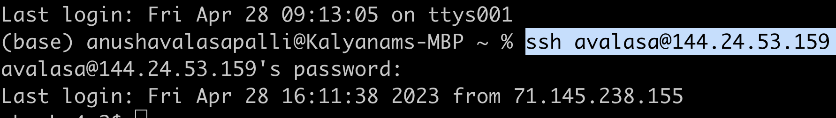

Now you will be logged in.

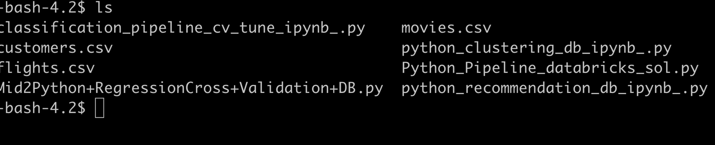

**ZEPPELIN:**

Suppose you use Zeppelin to write and run the code instead of data bricks. You have to open another window in the terminal or git bash, add the below command, and give the password the same as the user name.

ssh -N -L 8080:localhost:8080 [avalasa@144.24.53.159](mailto:avalasa@144.24.53.159)

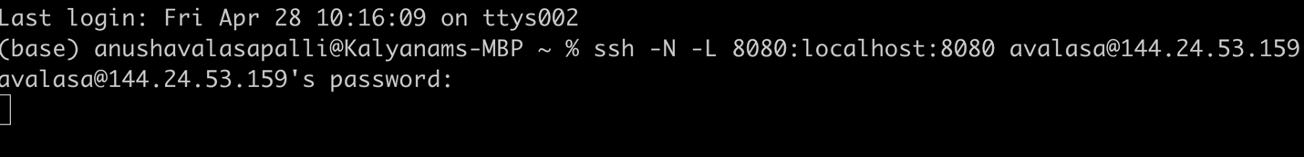

Click on this URL to connect to the port 8080 for Zeppelin <http://localhost:8080/> to import the files.

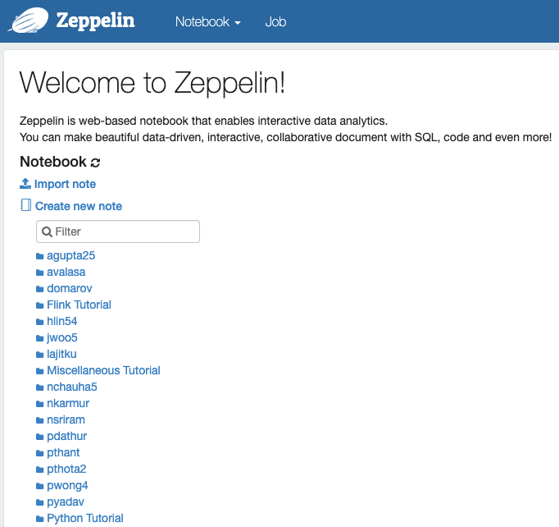

**STEP 2:** transfer files from the local to Hadoop local server; open a new window and paste the below command.

scp downloads/US_Used_Cars_Data.csv [avalasa@144.24.53.159](mailto:avalasa@144.24.53.159):~

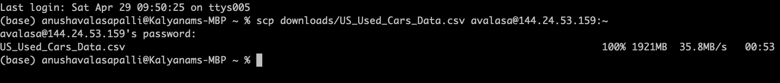

**STEP 3:** Use the below command to upload the US_Used_Cars_Data.csv file from the local server to HDFS.

hdfs dfs -put US_Used_Cars_Data.csv.

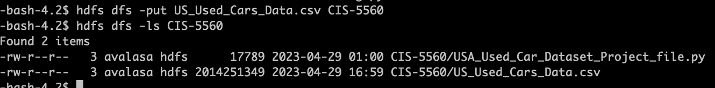



To check that the file is uploaded in the hdfs, use the hdfs dfs -ls command

Now we can see the US_Used_Cars_Data.csv file in the hdfs.

**STEP 4:** **Create a directory, “CIS5560” to put the file to HDFS**.

1. a. Run the following HDFS command to create the directory in HDFS.
   * 1. hdfs dfs -mkdir CIS-5560



1. **b. Next, you can run the following shell command to put the file in the respective directory.**
2. hdfs dfs -put US_Used_Cars_Data.csv CIS-5560/



**To Check that the US_Used_Cars_Data.csv file is uploaded into the CIS-5560**



**Now we have to upload the .py file to the hdfs which is the same as how we did for US_Used_Cars_Data.csv**

scp downloads/ usa_used_car_dataset_project.py [avalasa@144.24.53.159:~](mailto:avalasa@144.24.53.159:~)

hdfs dfs -put usa_used_car_dataset_project.py.

hdfs dfs -put usa_used_car_dataset_project.py CIS-5560/

hdfs dfs -ls CIS-5560



**To open the usa_used_car_dataset_project.py file in the hdfs**

vi usa_used_car_dataset_project.py

Changing PYSPARK_CLI = True

**STEP 5:** **To run the usa_used_car_dataset_project.py in spark-submit**

spark-submit --conf spark.driver.memory=8g --conf spark.executor.memory=8g usa_used_car_dataset_project.py



Change the file_location as "/user/avalasa/ US_Used_Cars_Data.csv "

file_location = "/user/avalasa/ US_Used_Cars_Data.csv "

**Results From Pyspark Submit:**

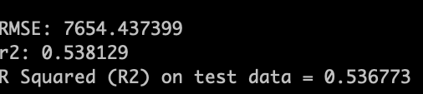

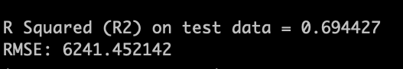

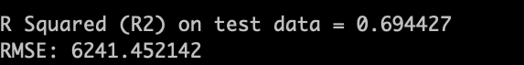

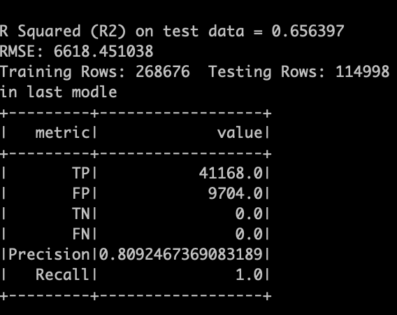

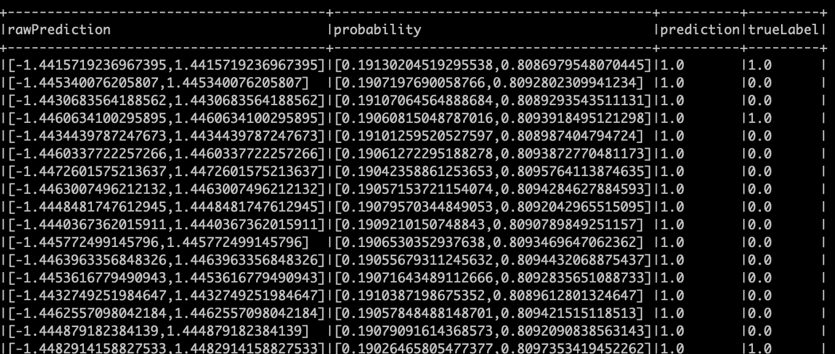

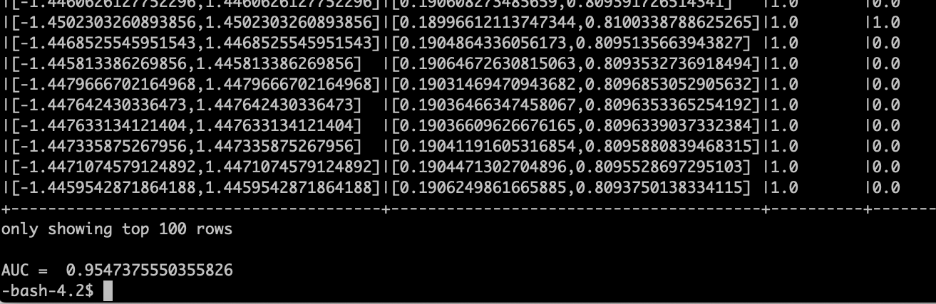

**Compare the Results**

Once you run all the Regression models, you can compare the results of all the Regression models. The Results should look something like the below. According to the Comparison table below. We can arrange various Regression Algorithms in the below order.

Based on time:

GBT> DT>RT> LR (GBT taking the most time and LR taking the least)

Based on accuracy:

GBT> DT>RT> LR (GBT having the best accuracy and LR having the least)

|  |  |  |
| --- | --- | --- |
| **Algorithm** | **Results** | **Time is taken to fit the model.** |
| Linear Regression (LR) | R2: 0.4335  RMSE: 8858.725 | 3.68 Minutes |
| Random Forest Regression (RF) | R2: 0.63  RMSE: 7100.234 | 6.55 Minutes |
| Gradient Boost Tree Regression (GBT) | R2: 0.67  RMSE: 6635.78 | 33.14 Minutes |
| Decision Tree Classifier | Precision: 0.9147  Recall: 0.967  AUC: 0.94 | 10.55 Minutes |

Thus, even though the GBT model takes the most time to run, it is the best model, with R2 closer to 1 and the least RMSE value.

**References:**

1. URL of Data Source: <https://www.kaggle.com/datasets/ananaymital/us-used-cars-dataset>

2. URL of your GitHub: <https://github.com/anushavalasapalli-97/CIS-5560-US_USED_CARS_PROJECT->

3. URL of References:

<https://spark.apache.org/docs/2.2.0/ml-pipeline.html>

<https://spark.apache.org/docs/latest/ml-tuning.html>

4. Databricks Html File URL:

<file:///Users/anushavalasapalli/Documents/CSULACOURSES/Spring2023/IntroductionToBigdata/Project/CIS_5560_Project/USA_Used_Car_Dataset_Project%20.html>